**USER GUIDELINE  
EVOWASTE SERVICE ACTIVATION**

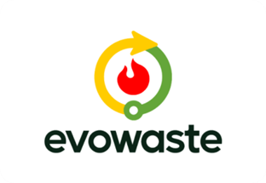

Application Name: Evowaste Activation and Web Admin

Version: 1.1

Date: 18th July 2025

Delivered By: FPT Software Indonesia

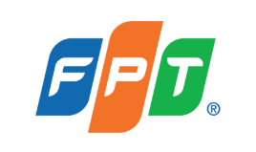

**APPROVAL SHEET**

**User Guideline Document**  
**System/Application Name**: Evowaste Activation and Web Admin  
**Version**: 1.1 (English Version)  
**Date**: July 18, 2025

This document has been prepared as a user guide and has been reviewed and approved by the relevant parties.

**FPT Software Indonesia**

| **Name** | **Position** | **Signature** | **Date** |
| --- | --- | --- | --- |
|  |  |  | July 18, 2025 |
|  |  |  | July 18, 2025 |
|  |  |  | July 18, 2025 |

**Evowaste / KMP**

| **Name** | **Position** | **Signature** | **Date** |
| --- | --- | --- | --- |
|  |  |  | July 18, 2025 |
|  |  |  | July 18, 2025 |

Evowaste Service Activation User Guide

1. **Introduction**

This guide is designed to ensure a precise and efficient service activation process. Evowaste Activation includes a module containing documentation related to service usage, a review of the machines to be installed to ensure they meet operational requirements, and verification of Company Details, Device Details, and Evowaste Services to ensure feasibility and readiness for installation.

This guide also includes steps for client registration via the admin web, which is a crucial part of the Evowaste system integration process for activation and Evowaste admin registration. Please ensure you read this guide carefully and have all necessary information and documents ready.

1. **General Requirements**

* Supported Browsers: Google Chrome, Microsoft Edge
* Screen Resolution: 1920 x 1200 pixels (WUXGA)
* Stable Internet Connection
* Additional Plugins: Not required (unless otherwise stated)

1. **How to Access Activation Web & Admin Web**

**3.1 Activation Web**

1. Open URL: <https://evowaste.id/>
2. Click the “Activation” menu on the header or icon “Activation License” in the Footer
3. Enter License Code
4. Click the Activate Button

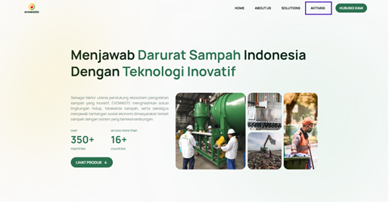

After successfully going to the Activation page, please enter your license code and click activate and you will be directed to the activation process.

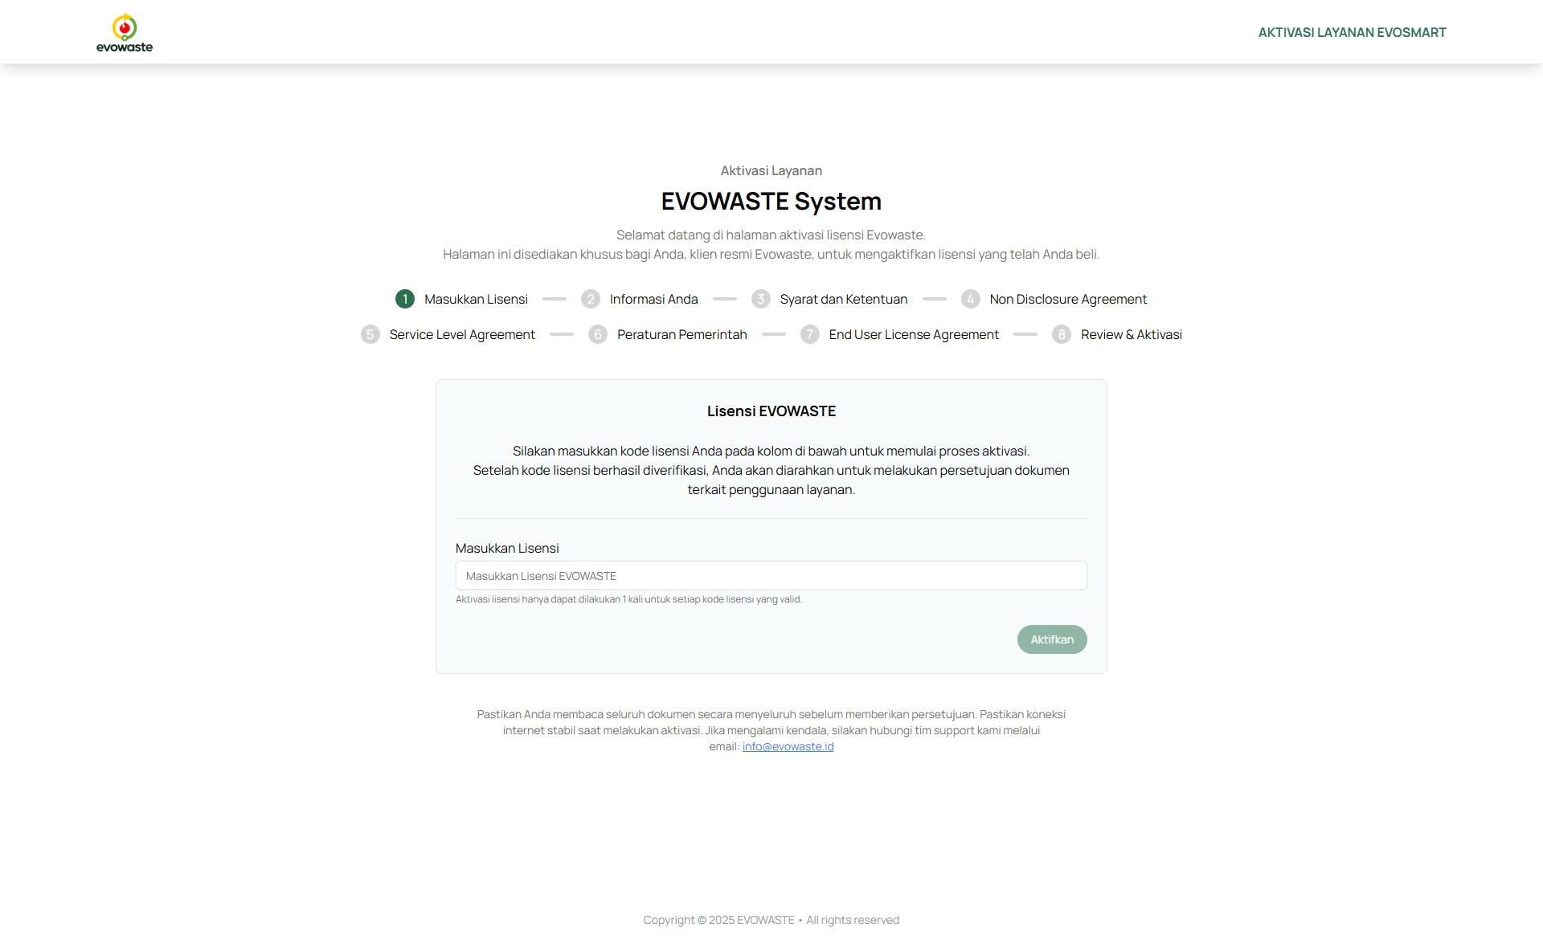

**3.2 Web Admin**

1. Open URL: http://43.218.202.164:3001/
2. Enter Email & Password
3. Click the Login Button

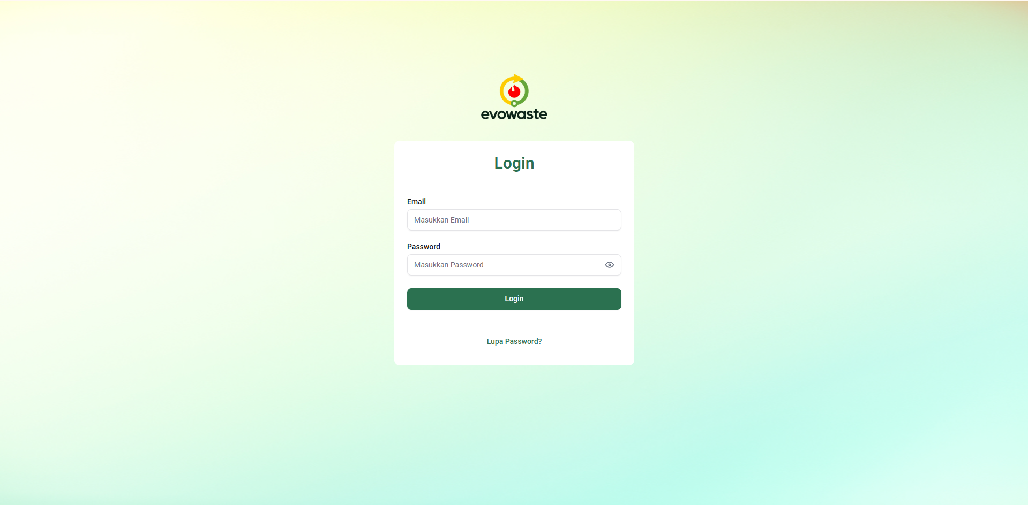

Once you have successfully logged in, you will be directed to the Dashboard page of the Evowaste Web Admin.

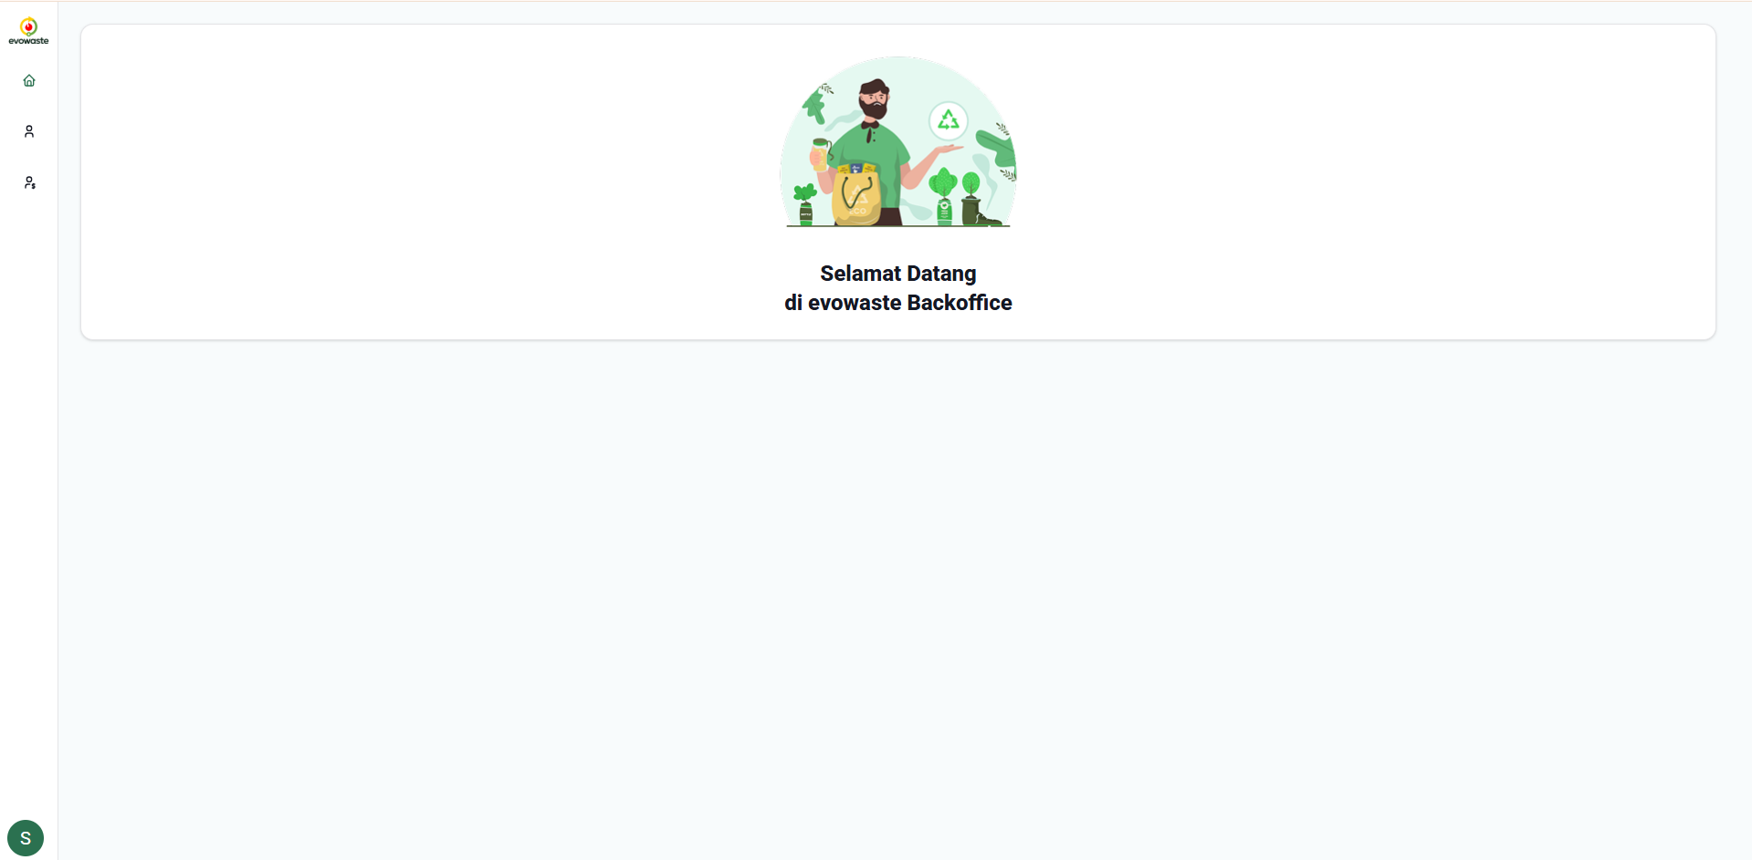

1. **Evowaste Web Admin**

The Web Admin is used by Evowaste teams as a centralized website for Evowaste user admin data and complete Evowaste client data. Admins can create user data that has access to create Evowaste client data.

Users who have access to Web Admin can create and change complete data from Evowaste clients and create license codes which will then be activated by Evowaste clients as proof that the client has agreed to subscribe to the product and service packages offered by Evowaste.

* 1. **Forgot Password and Log Out**

**Forgot the password**

The Evowaste Web Admin provides a password reset feature if you forget your login password. By clicking "Forgot Password" on the login page, you will be redirected to a page where the system can help you reset your password.

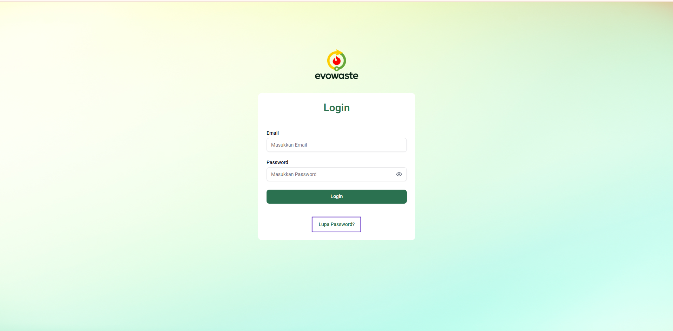

Enter your valid email address and the credentials you need to access the Evowaste Web Admin, then click the Submit button. You will then be redirected to an information page confirming that your password reset request has been received.

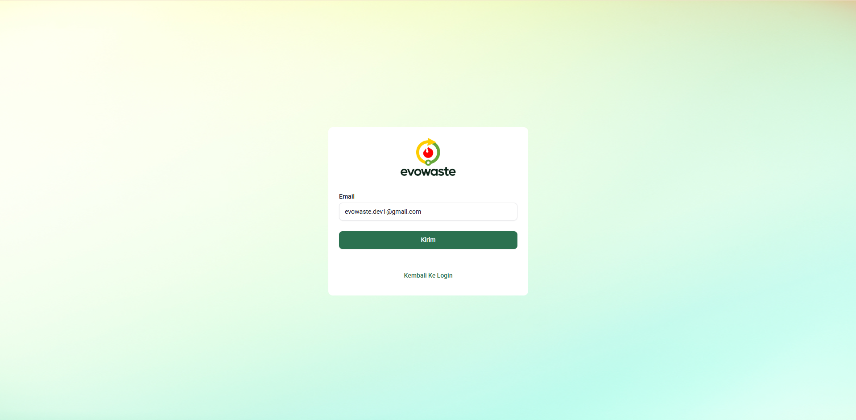

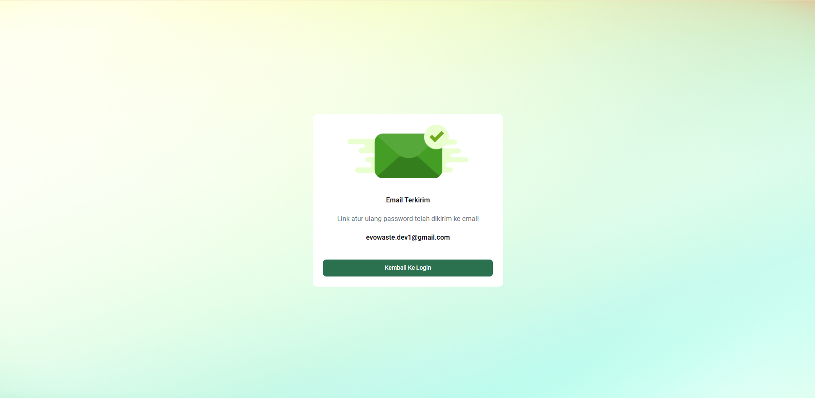

The system will send a link to reset your new password to your email. Click the Reset Password button to be redirected to the page where you can reset your password.

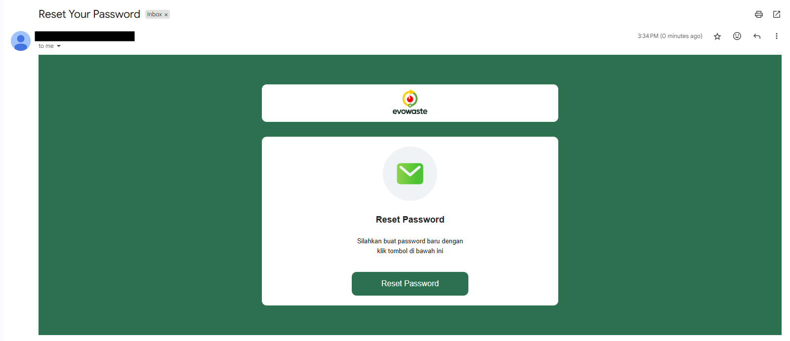

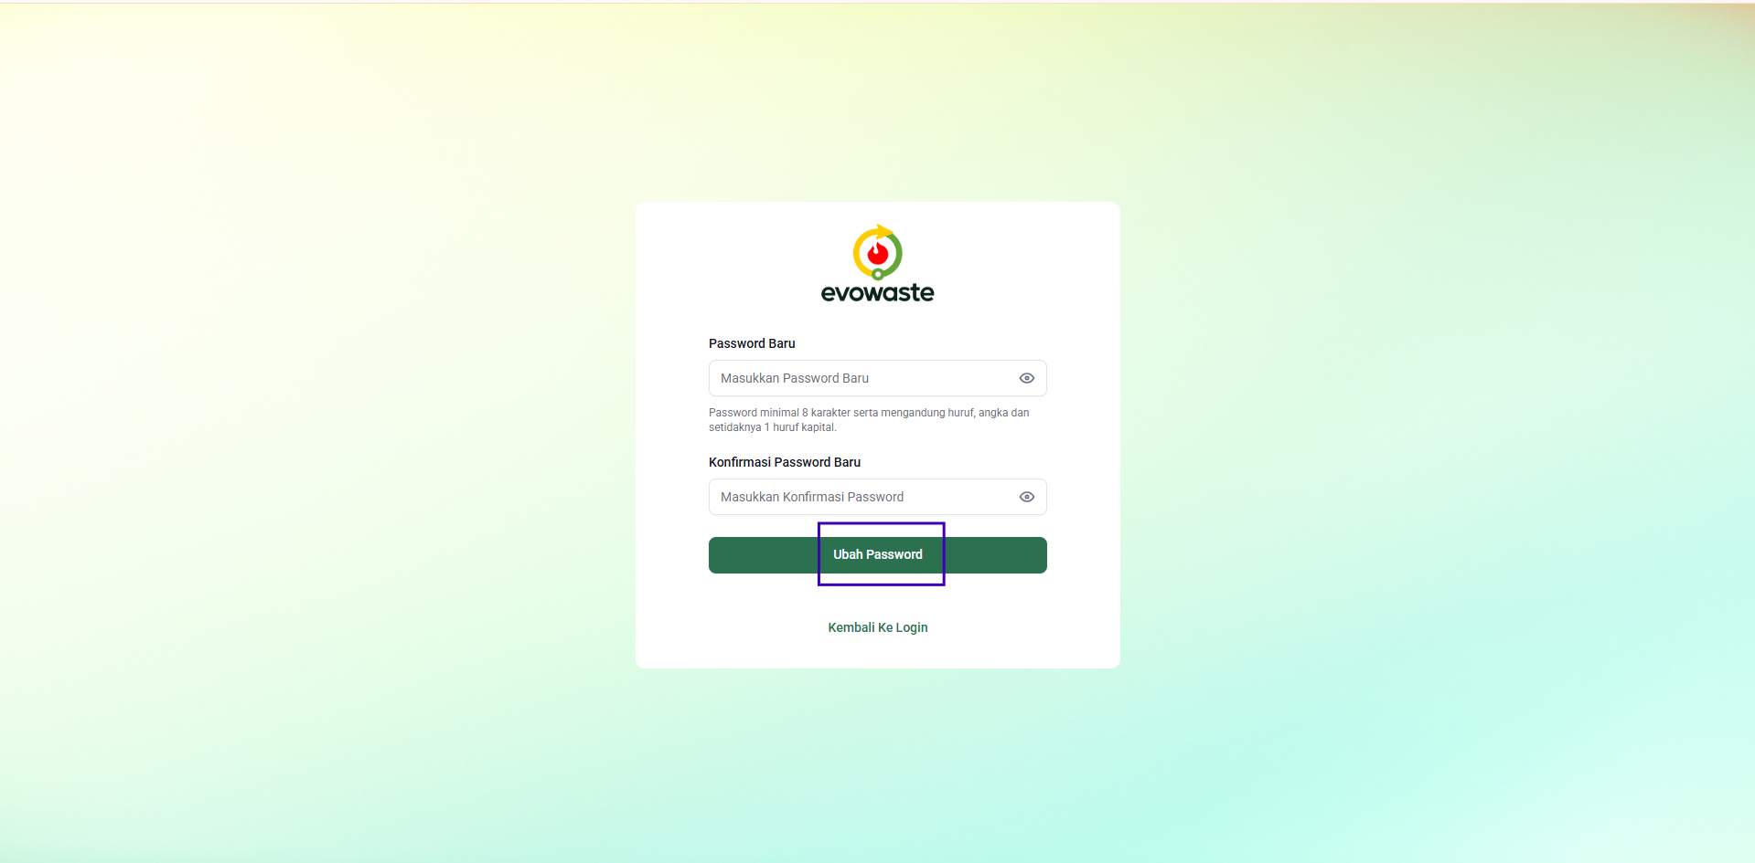

Click the Change Password button after creating a new password. Once your password reset is successful, you can return to the login page to log in using your new email address and password.

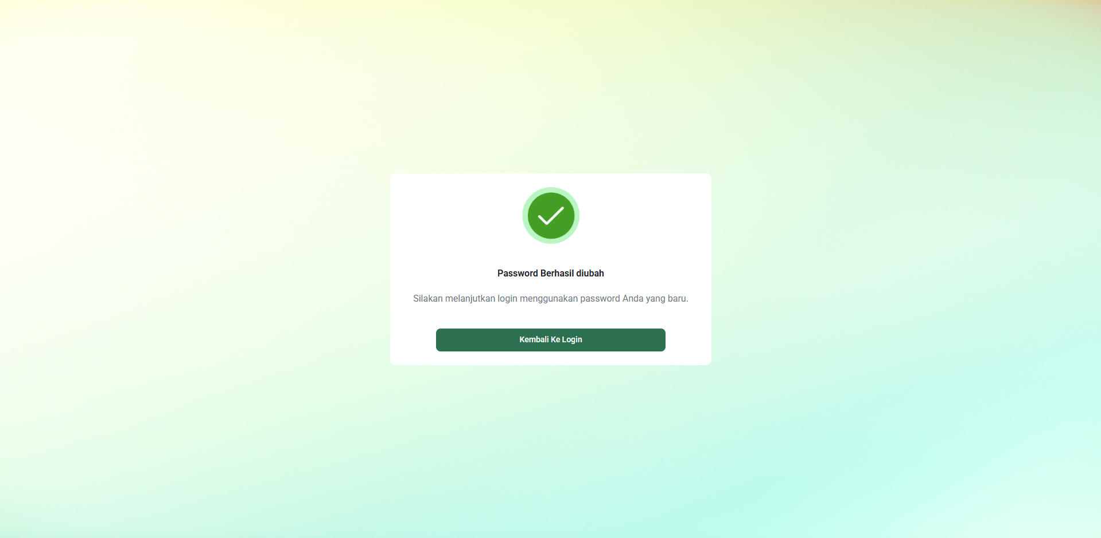

**Log Out: Click Profile Icon > Log Out**

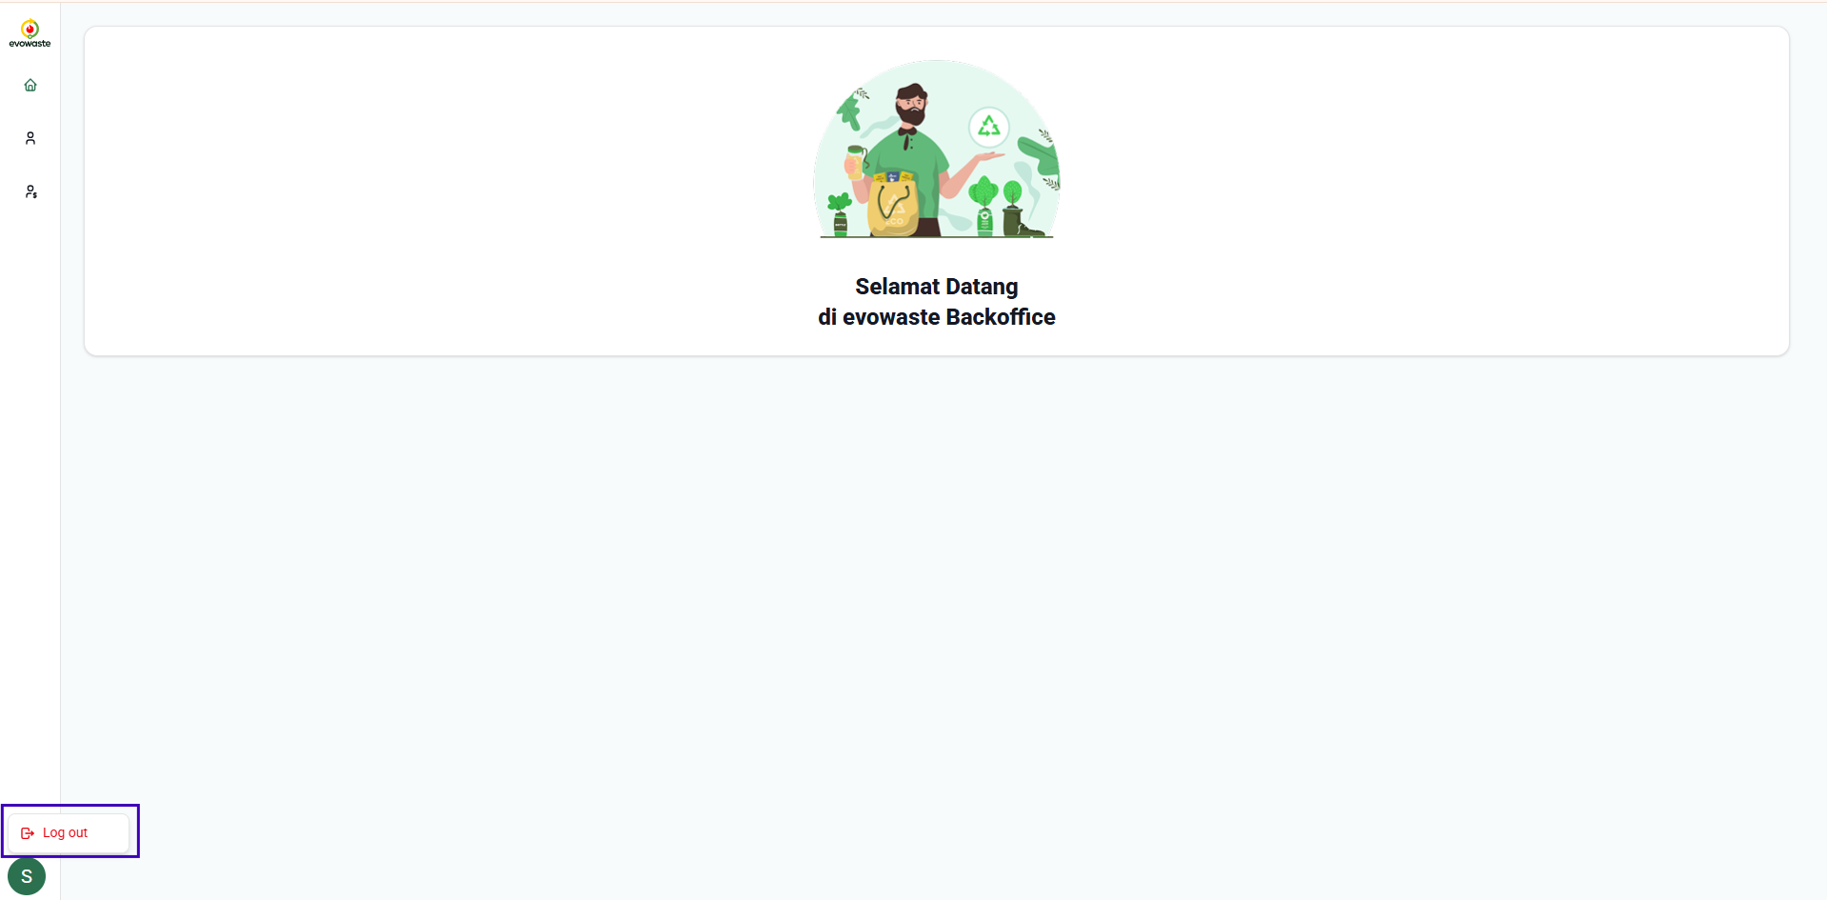

**4.2 User Management (Add, Edit, view and delete User data)**

The User Management menu provides features for you as an Admin or Evowaste marketing team to access the Evowaste Back Office Admin website. Those with credentials and authorization can create new user data that will have access to the Evowaste Back Office Admin website to further manage and use the Management Client features.

To access this feature, open the main menu on the left side of the page and select User Management. You'll then be directed to the Master Data User table, which displays a list of Evowaste admins with credentials to the Evowaste Web Admin.

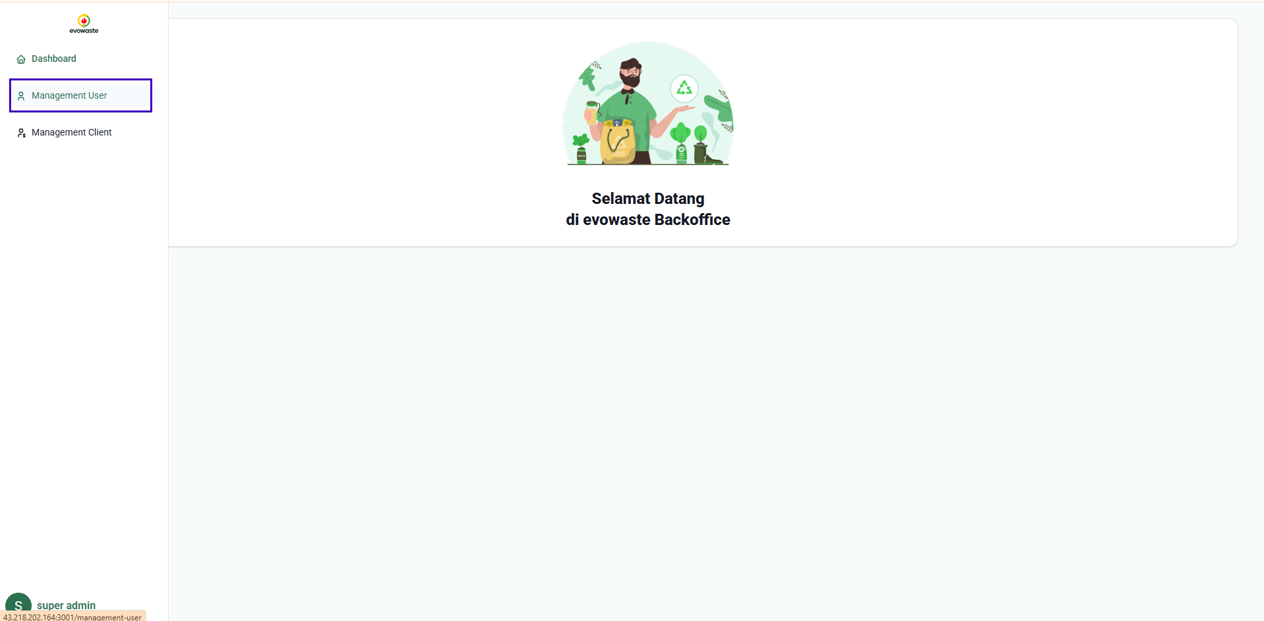

Enter keywords (Name/Email) into the search field to find a specific user in the table.

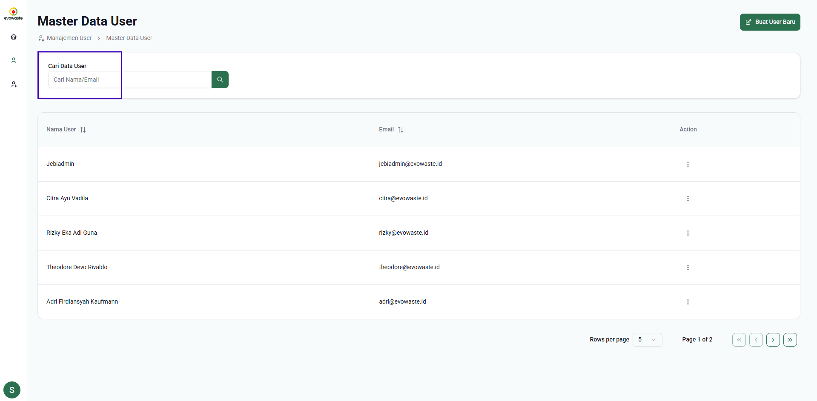

There are 3 main features in the User Management menu, where you can create new data, view details, edit data and delete data.

1. **Add User Data**

To create a new user, click the Create New User button in the User Management menu. You will then be redirected to the Create New User form.

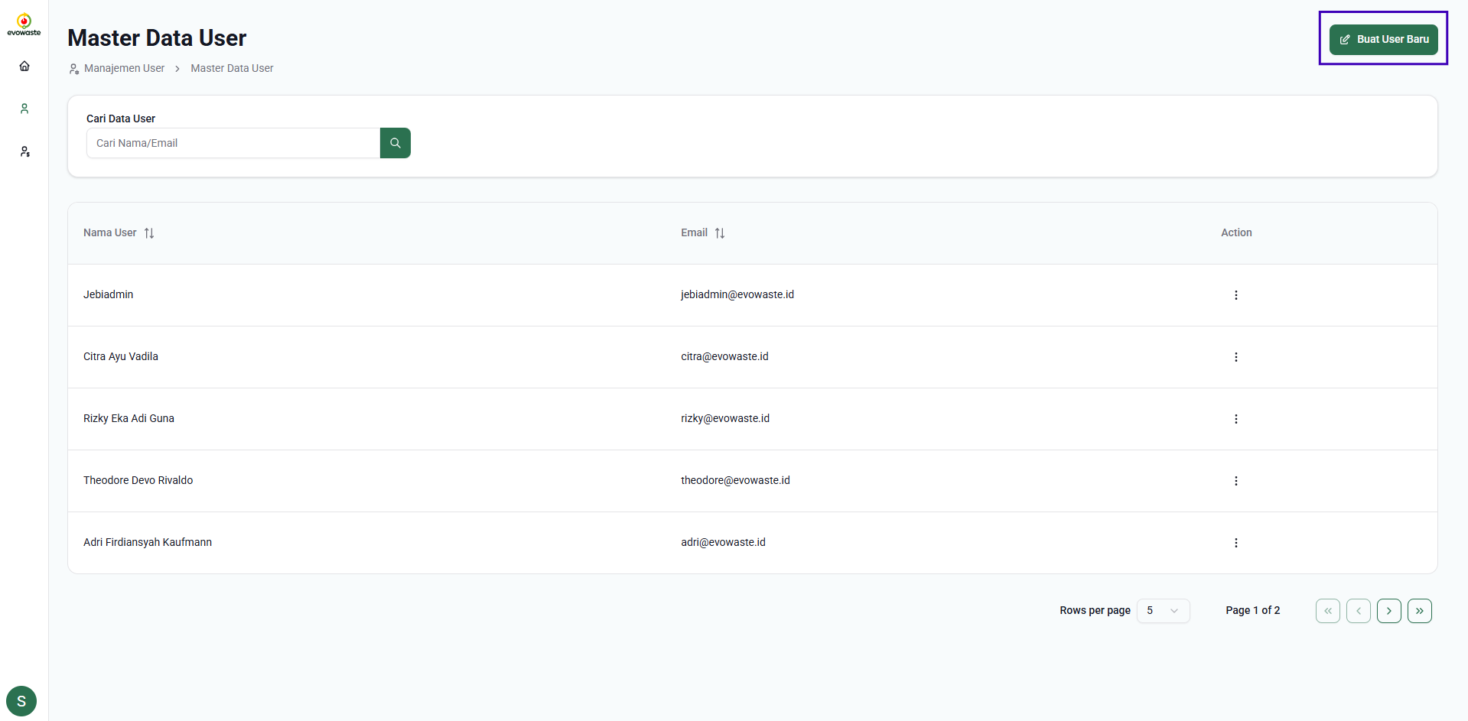

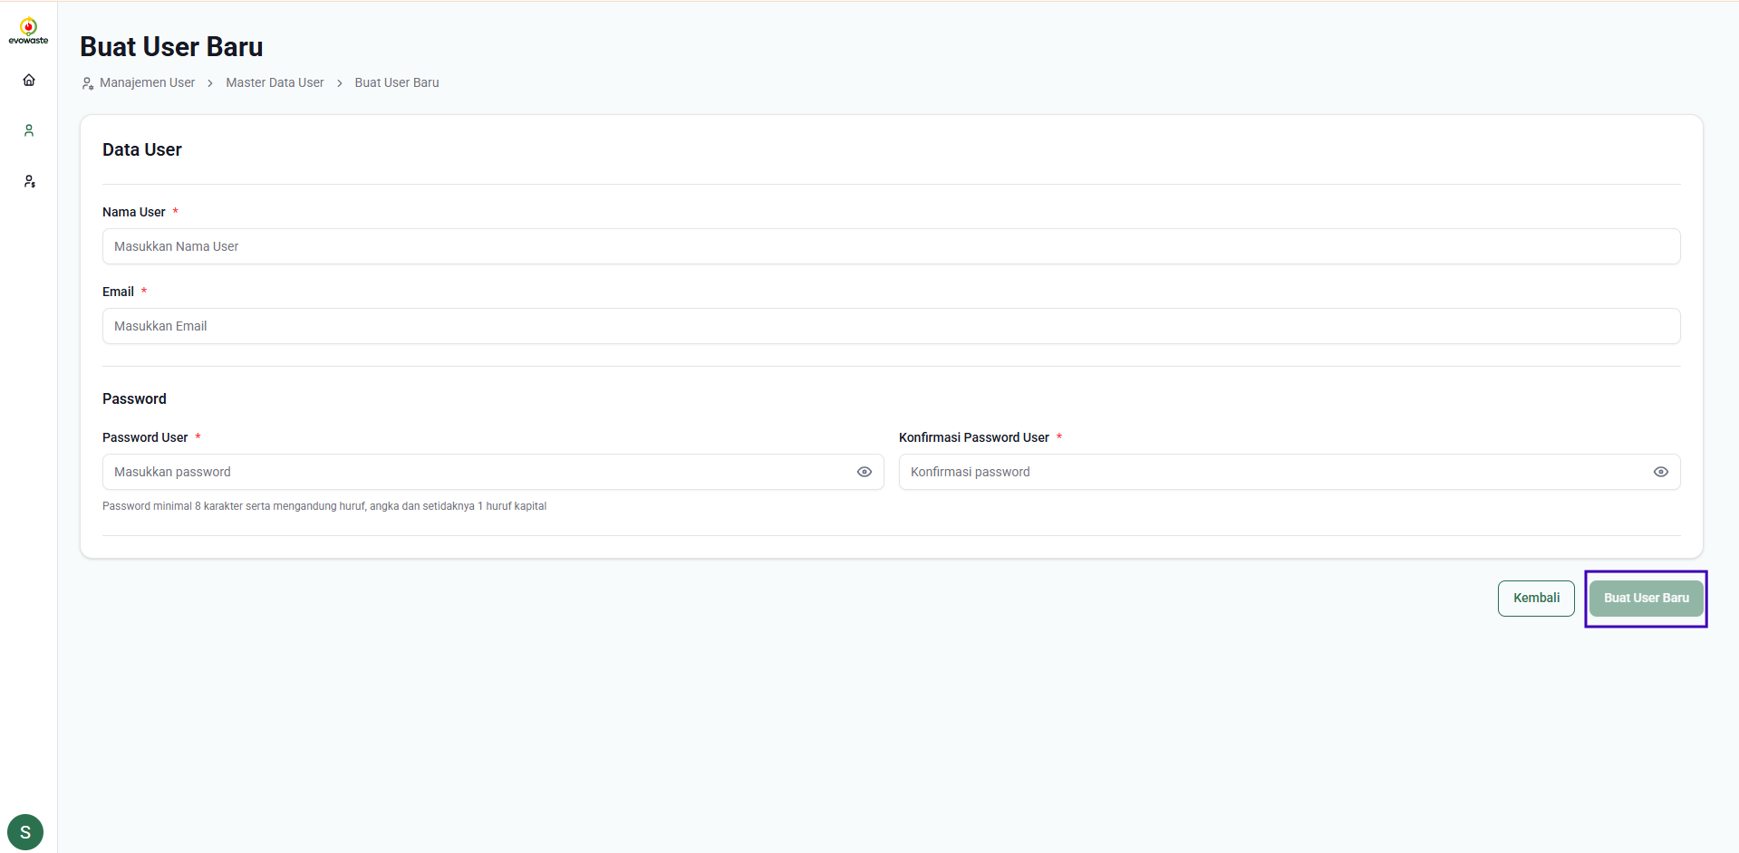

Enter all the required data completely, then click the "**Create New User**" button. The newly created user's data will be registered in the User Master Data table. The new user will receive login credentials for access to the Web Admin Back Office.

1. **View User Details**

Click the icon   then, select Details to view the details of the data in the User Master Data table. You will then be directed to the User Details page.

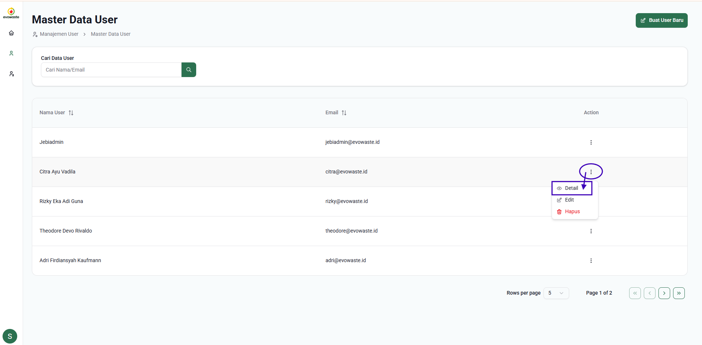

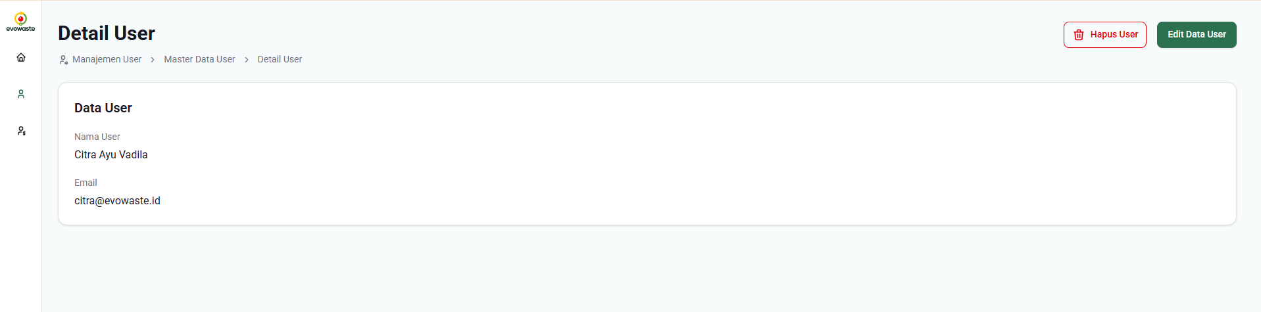

1. **Edit User Data**

You have 2 options to edit data in the user master data. You can click the icon  on the selected data then select Edit.

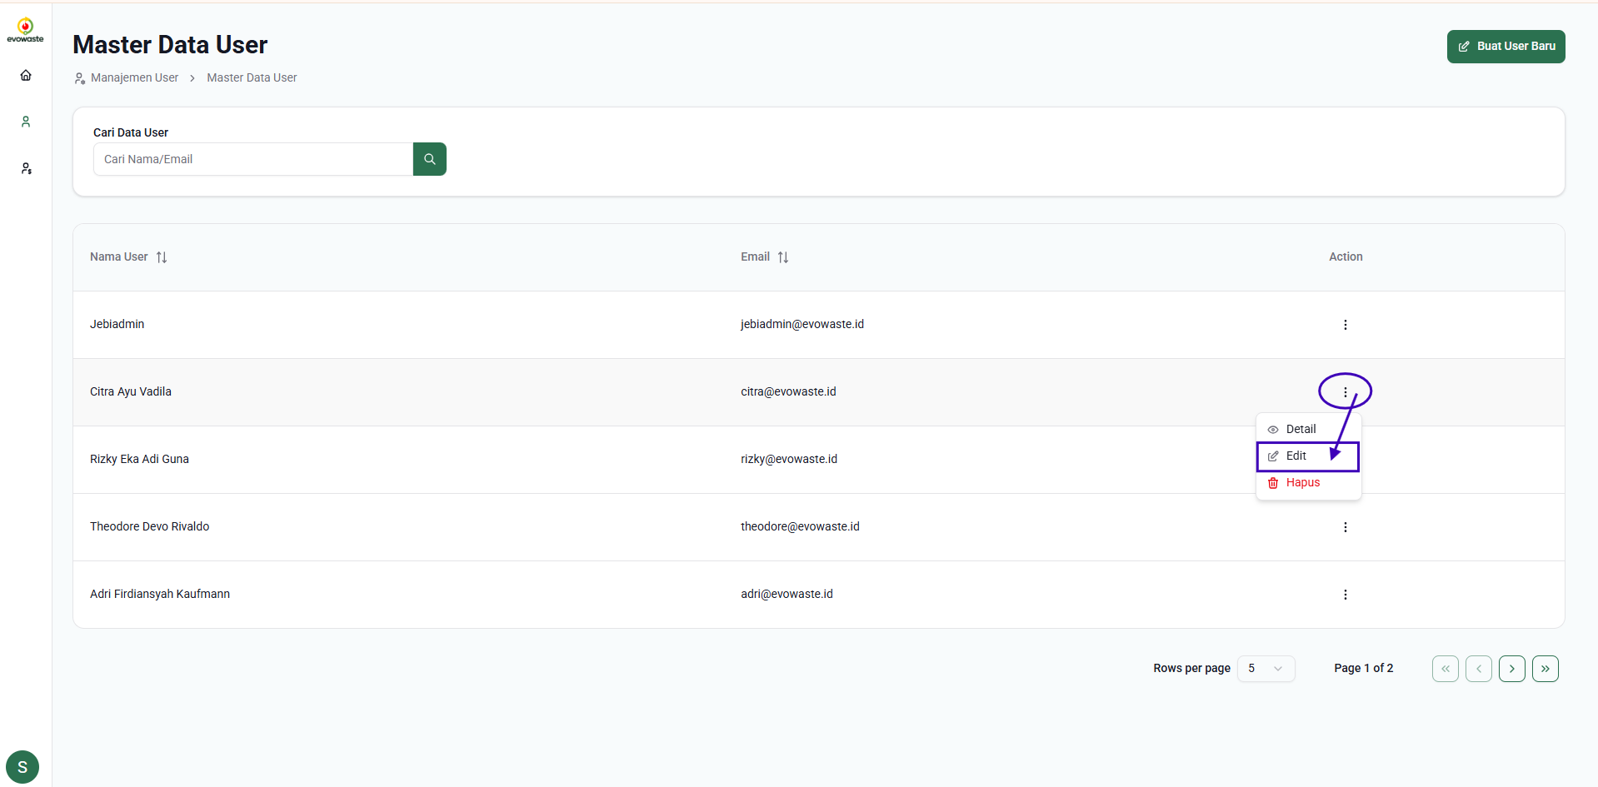

You can also select Details on the desired data then click the Edit User Data button on the User Details page.



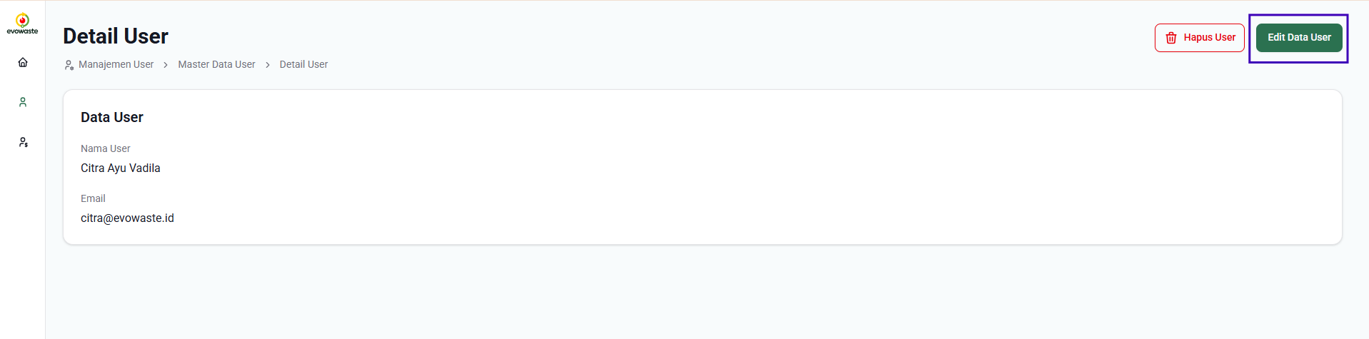

From the two options above, you will be directed to the Edit User Data page. Users can edit the data and then click the Save button to save the data. Successfully edited data will be saved in the User Master Data table.

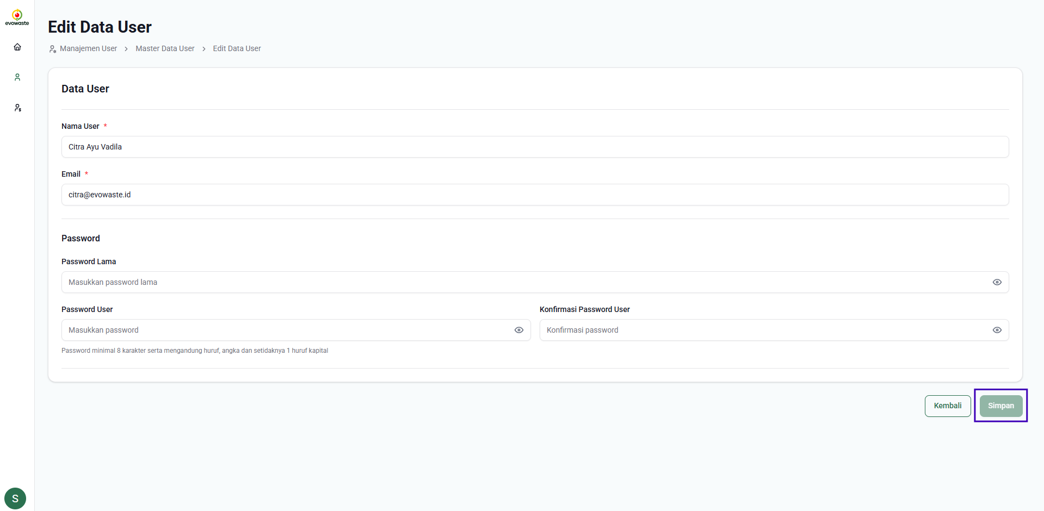

1. **Delete User Data**

To delete user data, the admin can click the icon  then select Delete.

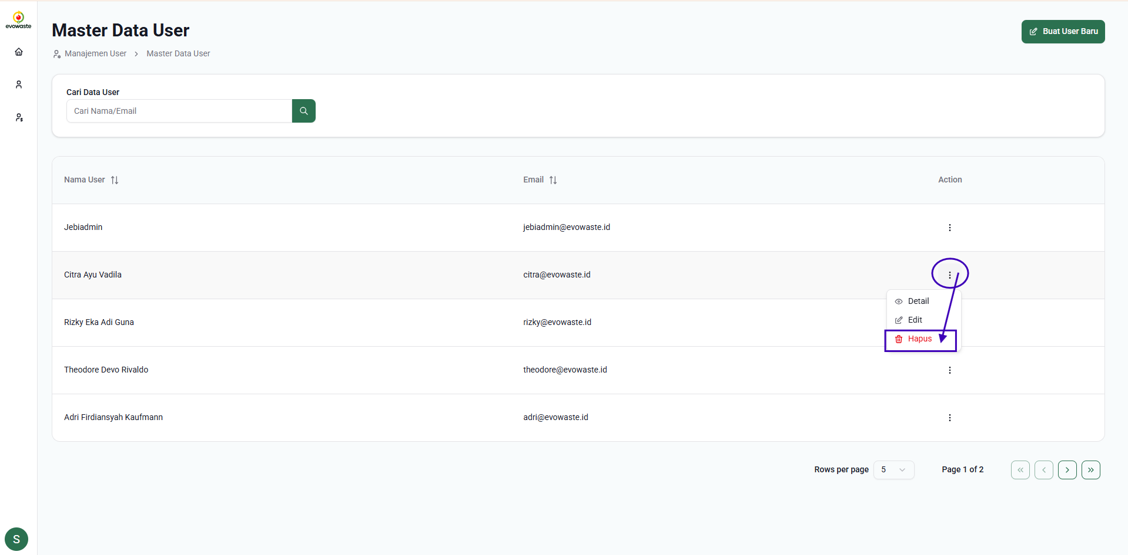

Or you can also view the user details and click Delete User.

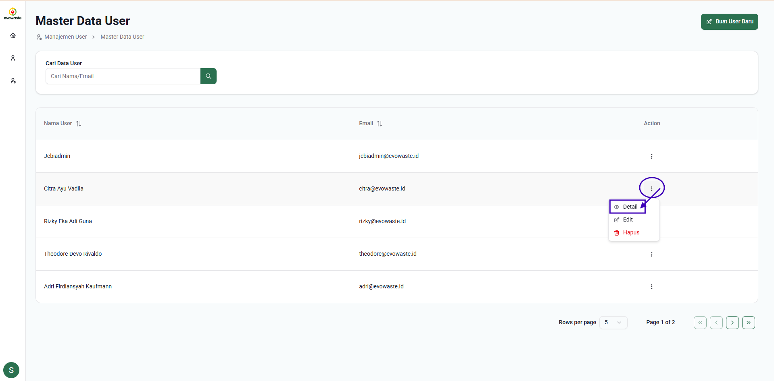

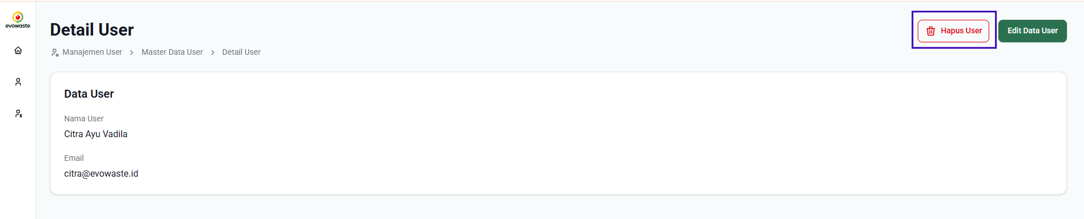

Then a popup will appear to confirm deleting user data and click the Confirm button.

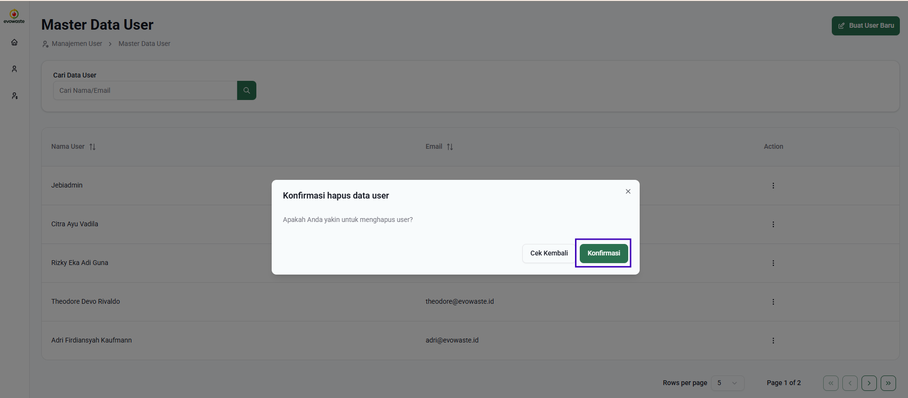

Then the user data has been successfully deleted, and you will return to the master user list page.

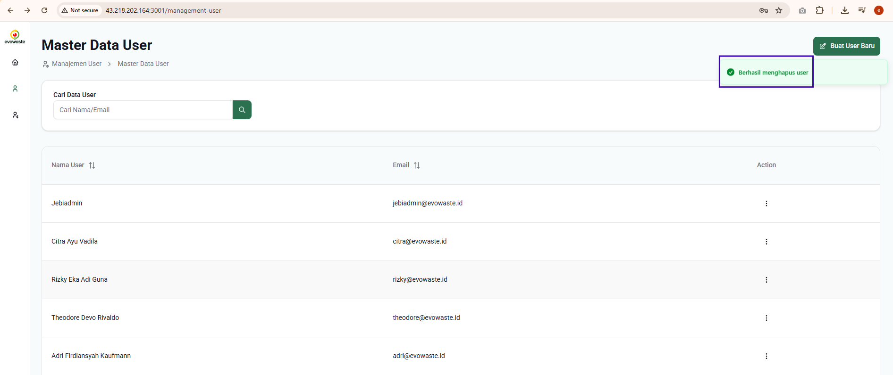

**4.3  Client Management (Add, Edit and View Client Data)**

**Master Client Management** is a feature in the Evowaste admin system that allows administrators to manage client data comprehensively and centrally. Through this feature, admins can register new clients by filling in detailed company information, data on the person in charge (PIC), machine specifications, license codes, and the Evowaste services used.

In addition, admins can also upload or link relevant legal documents such as cooperation agreements, NDAs, SLAs, and other licensing documents. This system also provides admins with access to view registered client data, add new client data, and update client data. With Master Client Management, client data management becomes more efficient, accurate, and well-documented.

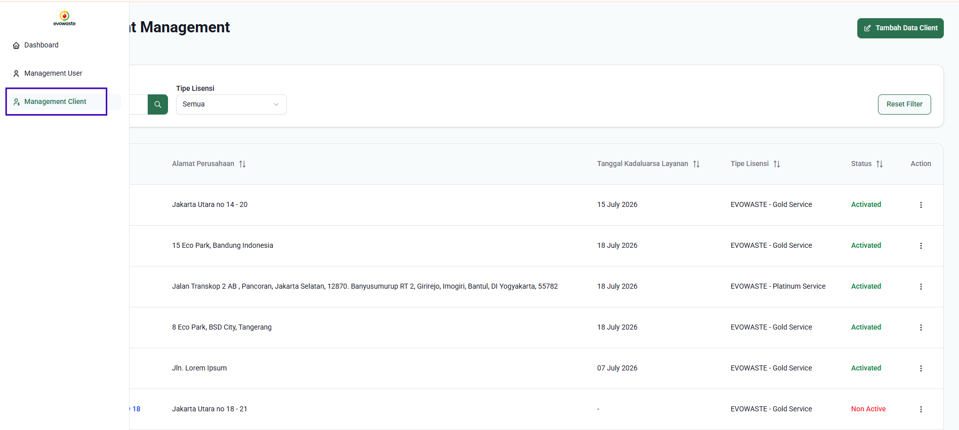

1. **Master client list**

**Master Client List** is the main display that displays the entire list of clients who have registered in the Evowaste system, both those who have been activated and those who have not been activated.

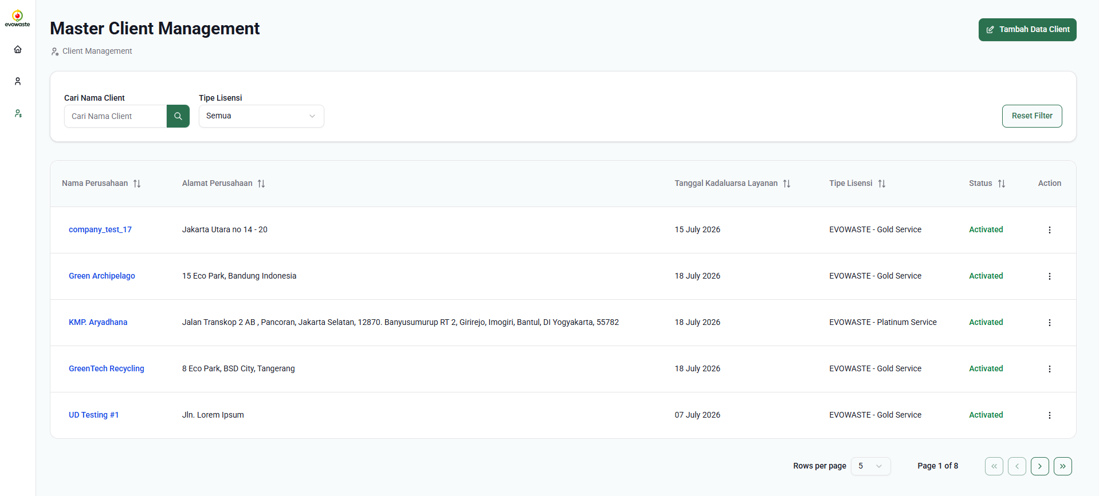

Through this page, admin can easily add new clients by clicking the "**Add Client Data**" button.

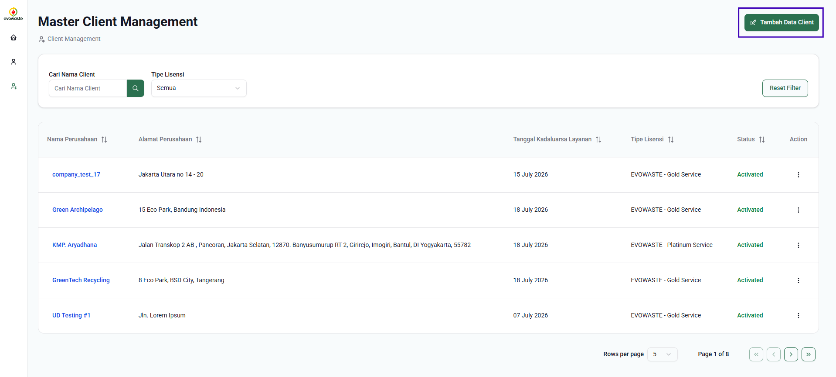

To make searching easier, there is a "Search Client Name" feature that allows admins to search for specific clients based on company name, as well as a "License Type" filter to filter data according to the license category used.

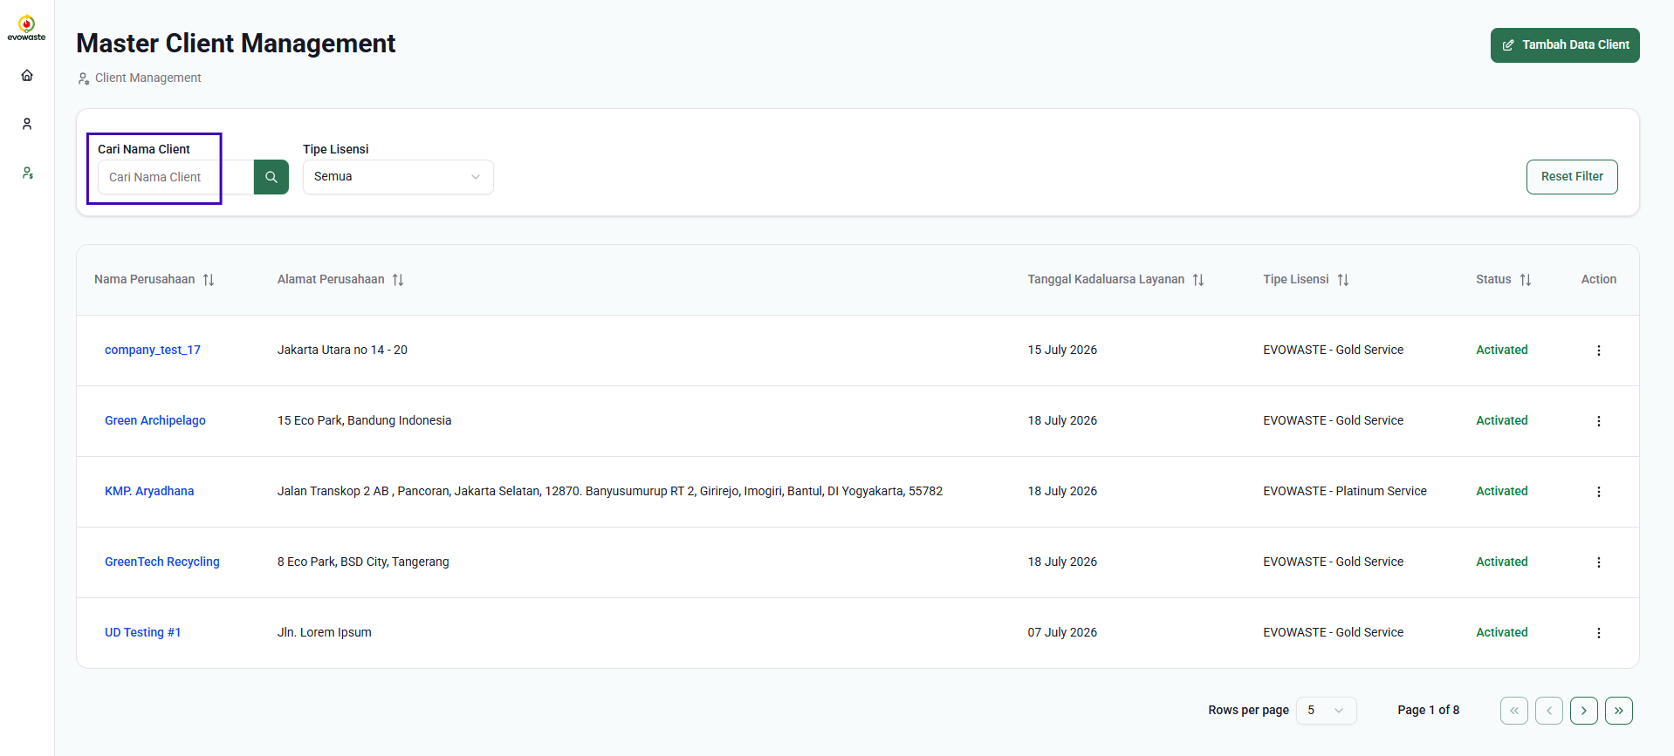

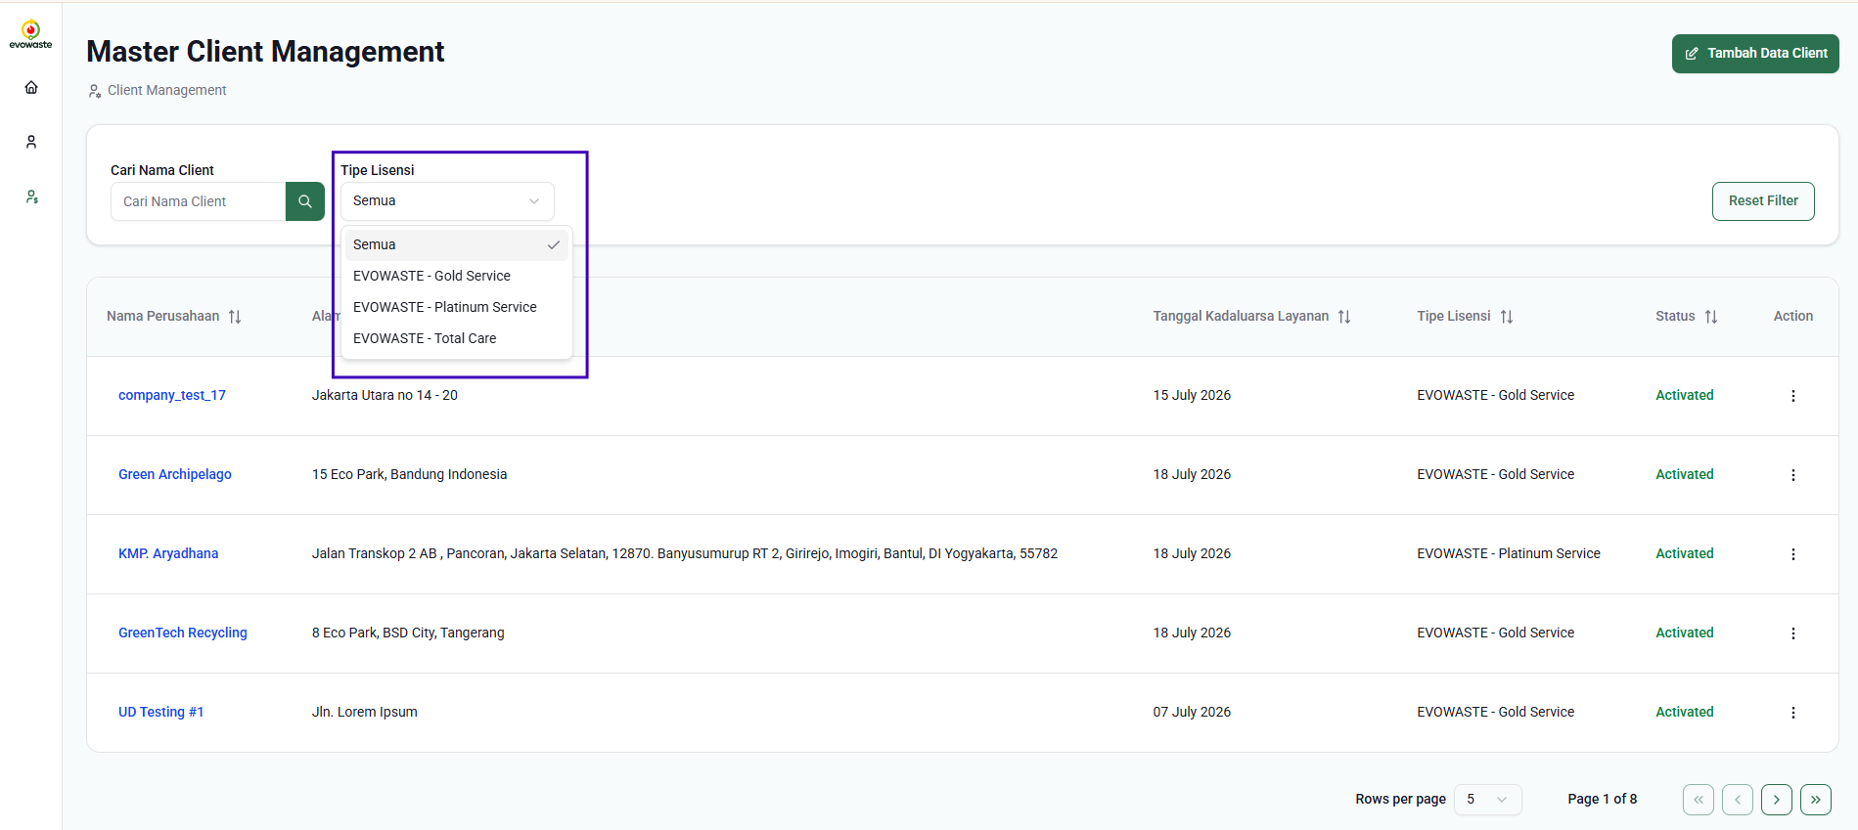

Admins can also view client details by clicking on the company name directly or via the Action menu, which provides options for viewing details or editing data.

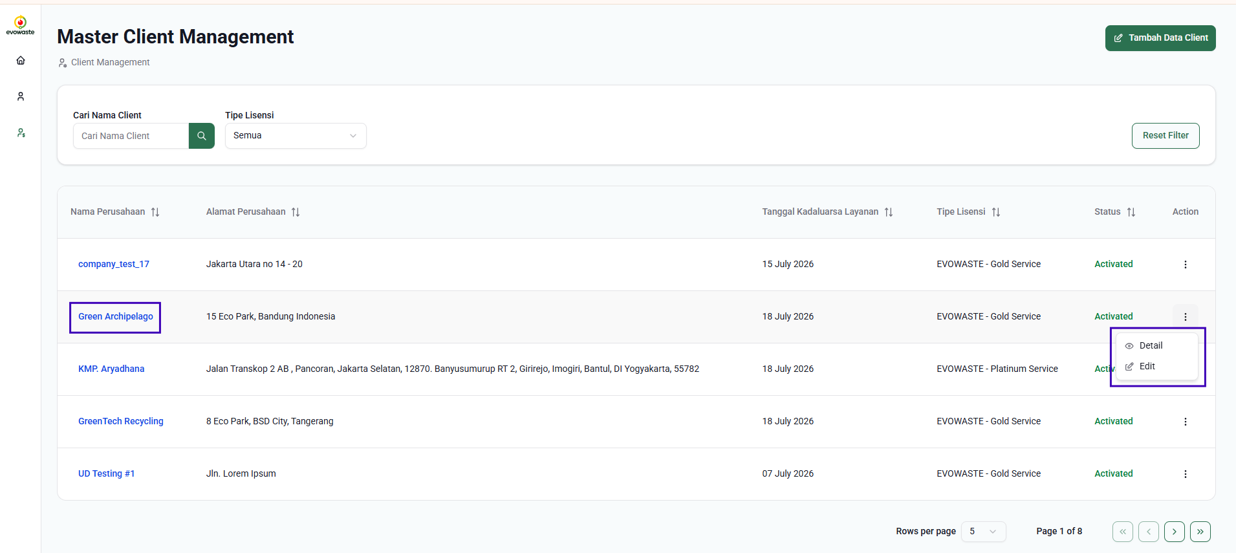

1. **Add Client Data**

After clicking the "Add Client Data" button on the Master Client List page, you'll be redirected to a form where you can complete your client details. This form consists of several main sections.



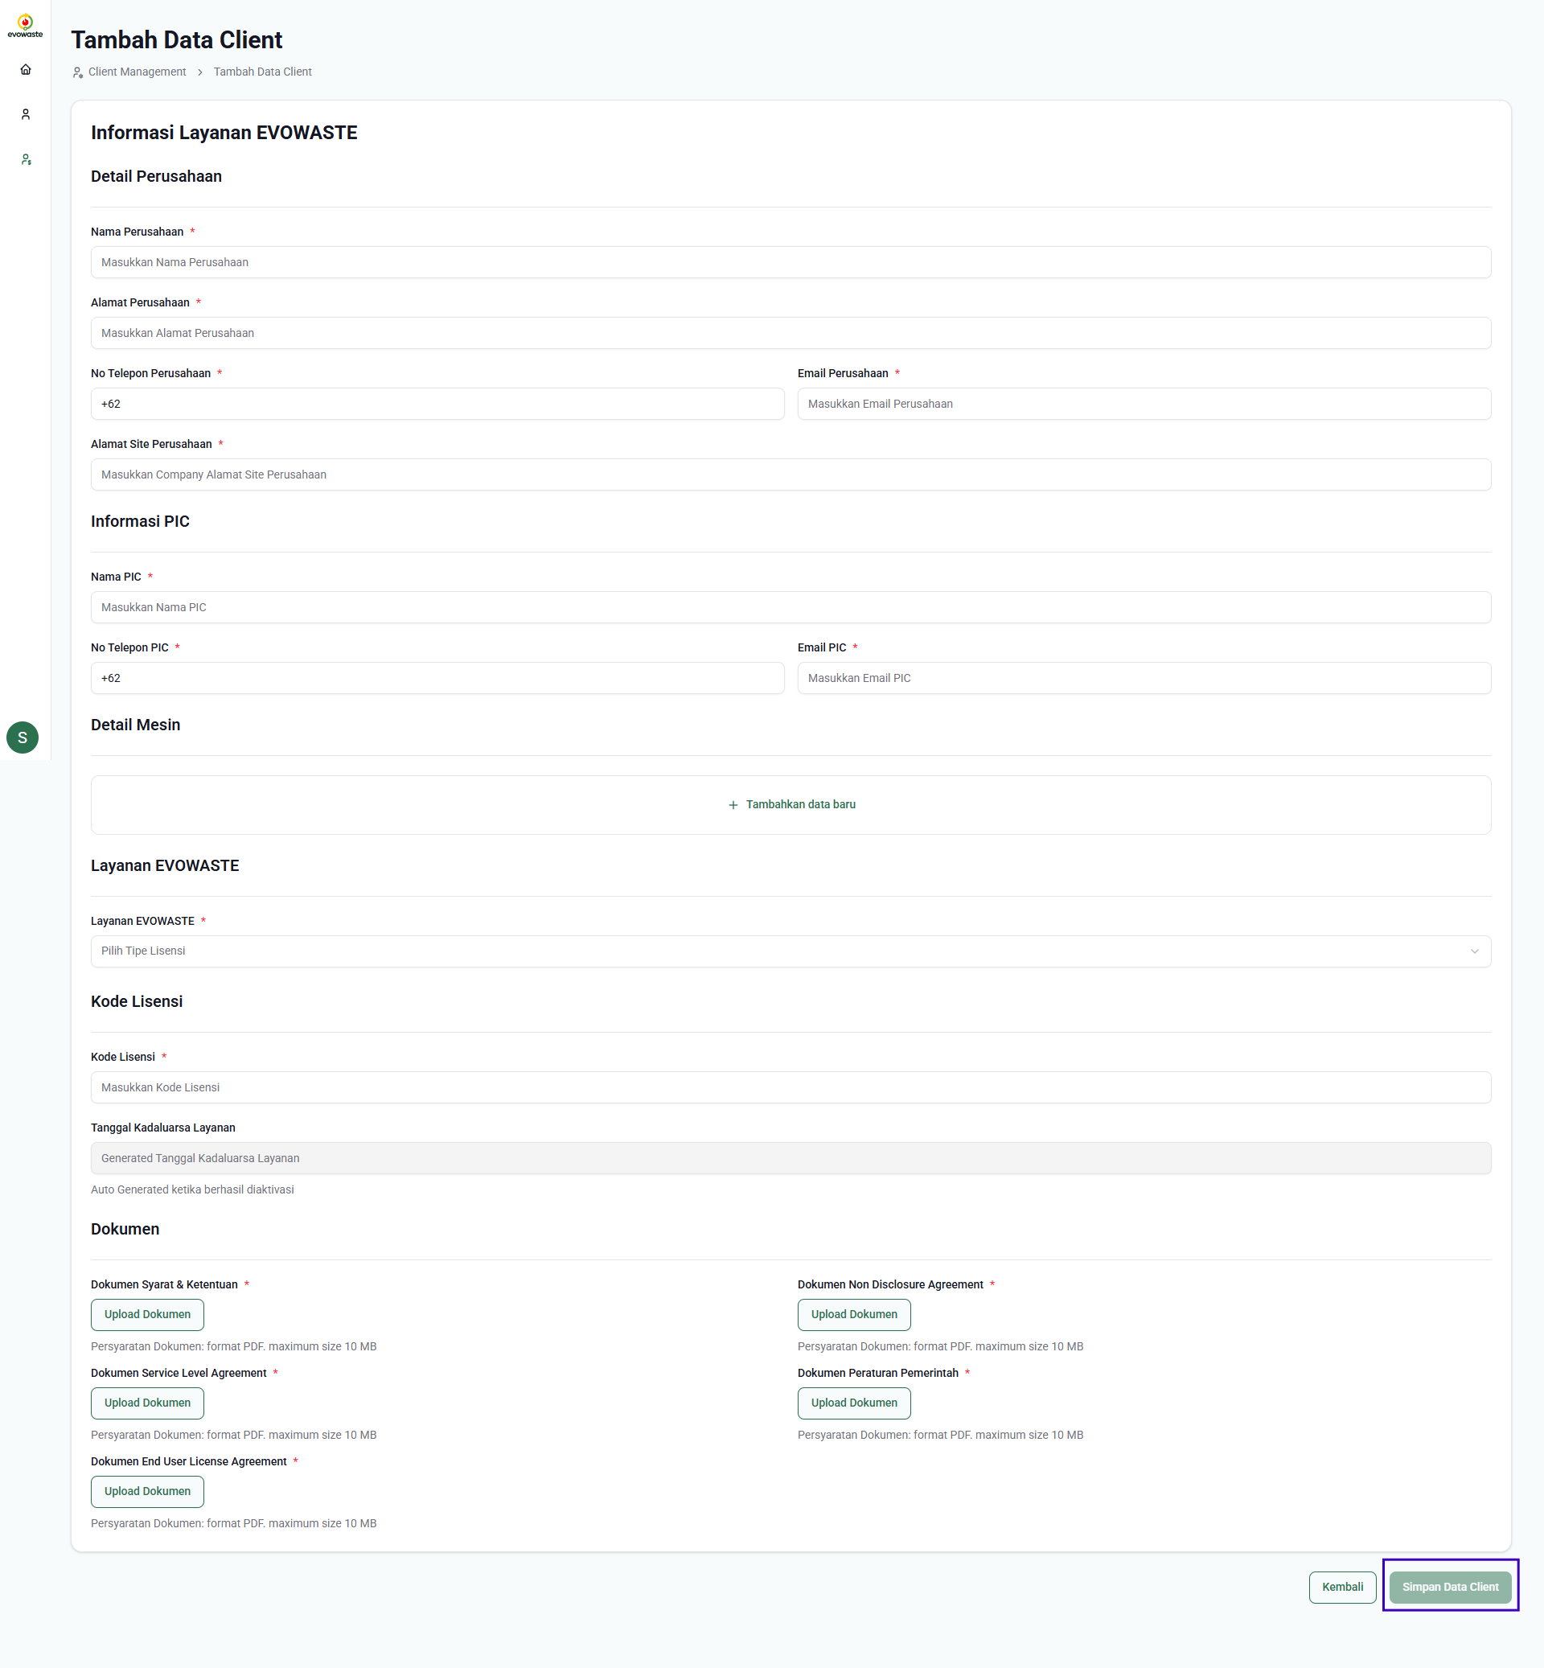

In the Company Details section, the admin needs to fill in information such as Company Name, Company Address, Company Phone Number, Company Email, and Company Website Address. Next, in the PIC Information section, enter the main person in charge's details, including the PIC's Name, PIC's Phone Number, and PIC's Email.

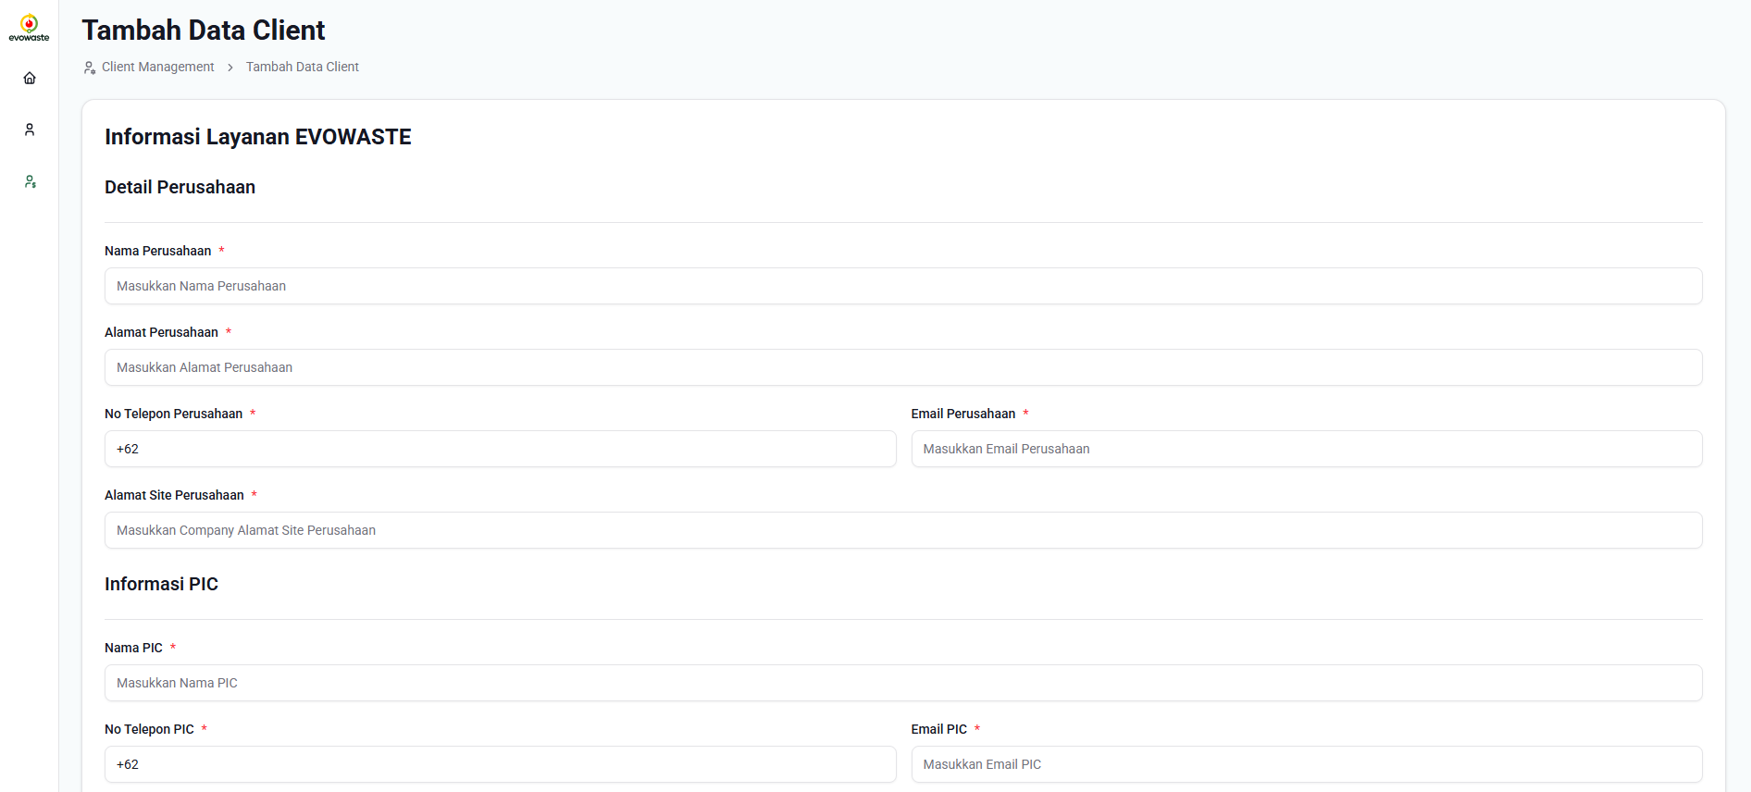

To add Machine Details, click the "Add New Data" button and enter information such as Machine Image, Machine Name, and Serial Number.

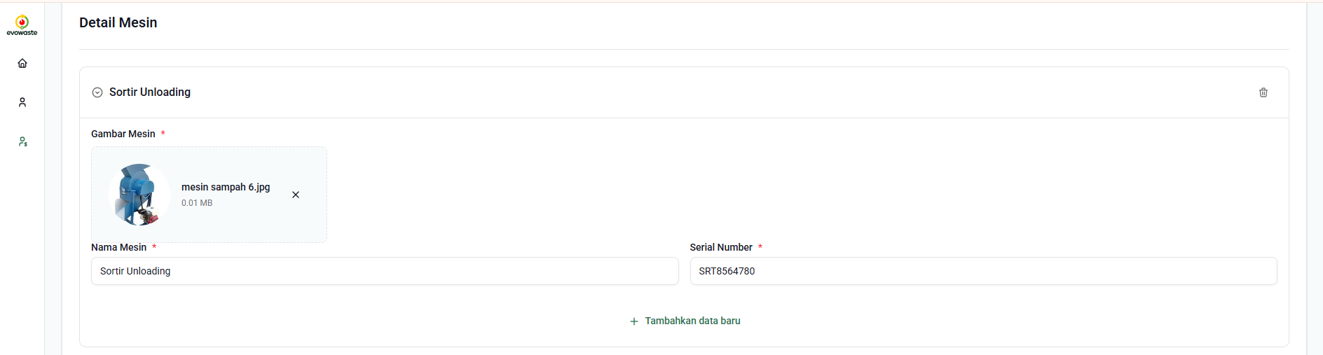

In the Evowaste Services section, select the type of service the client uses from the dropdown menu: Gold Service, Platinum Service, or Total Care. Then, enter the License Code the client will use.

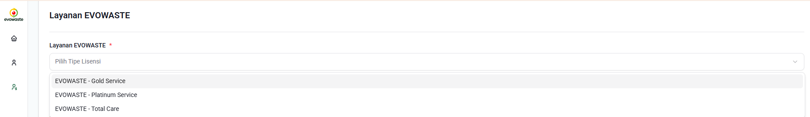

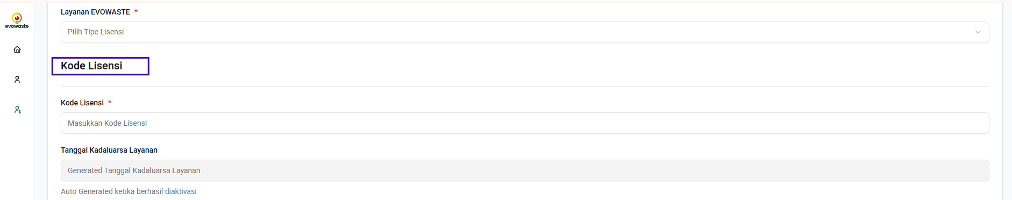

Finally, upload all necessary legal documents, such as Terms and Conditions, Non-Disclosure Agreement (NDA), Service Level Agreement (SLA), Government Regulations, and End User License Agreement (EULA).

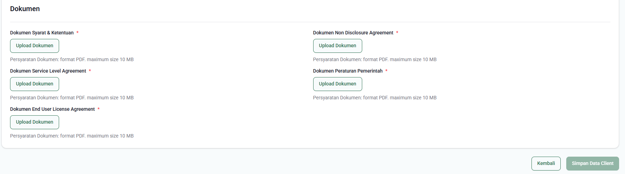

Once all forms and documents have been completed, the "Save Client Data" button will be activated. Click it to add the client data. Once the client data has been saved, you will be redirected to the master client list page.

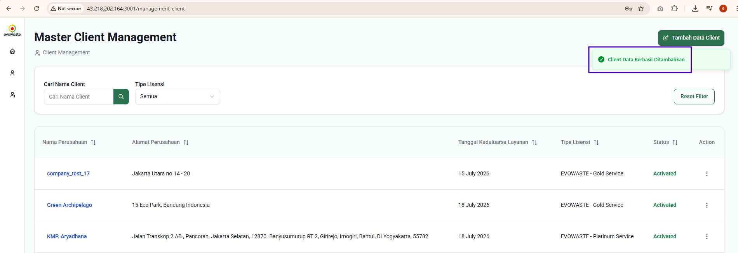

**Then you can copy and inform the Evowaste License Code to the client, to activate it.**

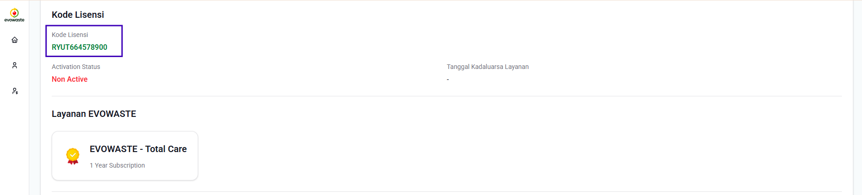

1. **Client Data Details**

The Client Data Details feature allows admins to access comprehensive information regarding client data registered in the Evowaste system. By clicking on a company name or using the "**View Details**" button in the action menu, admins can review all entered data, including company information, PIC contact information, machine details, service types used, license codes, and uploaded legal documents.

This view is designed to provide comprehensive visibility into client status and configuration, facilitating monitoring, data validation, and necessary operational support.

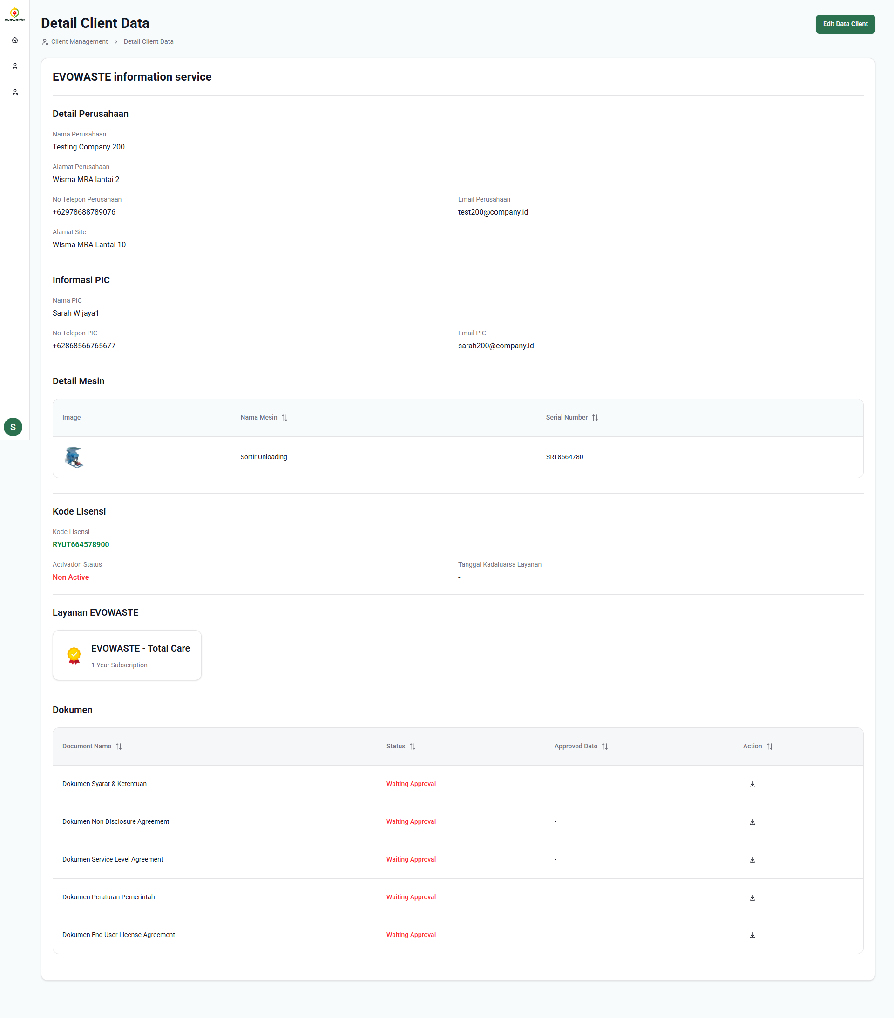

1. **Edit Client Data**

The Edit Client Data feature allows admins to make changes or updates to client information registered in the Evowaste system. Through the "**Edit**" menu on the client details page or client list, admins can update data such as company information, PIC contacts, machine details, service types, license codes, and replace or add legal documents. This feature is designed to ensure that all client data remains accurate and up-to-date and makes it easier for admins to make corrections if there are errors or changes in client requirements.

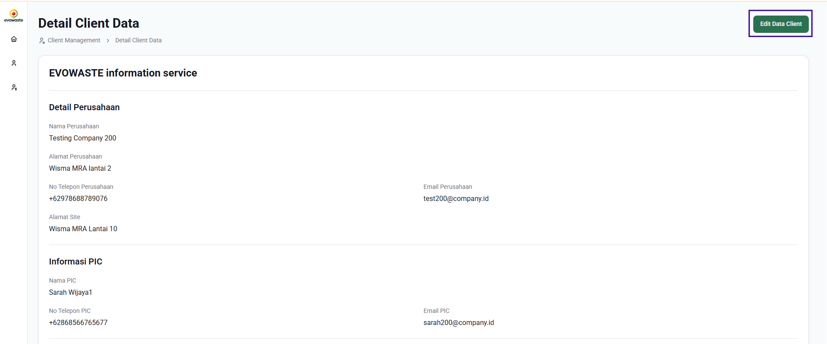   
   
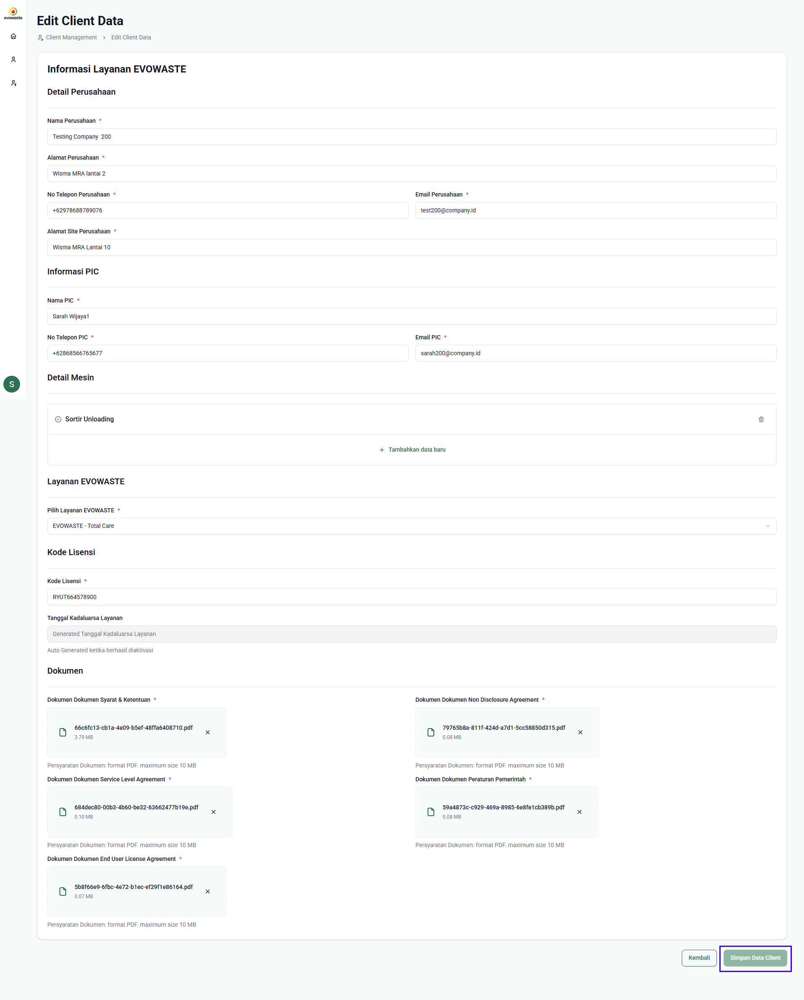

Once you've finished changing client data, click the "Save Client Data" button to save the changes. You'll then be returned to the master client management page.

1. **Evowaste Activation Web**

**Evowaste Activation** is a web platform specifically designed to facilitate the service activation process for clients in a fast, secure, and structured manner. Through this platform, clients can enter the license code provided and review details of the company, machine equipment, and Evowaste services they will use. In addition, clients are also required to agree to several legal documents, including Terms and Conditions, a Non-Disclosure Agreement (NDA), a Service Level Agreement (SLA), applicable Government Regulations, and an End User License Agreement (EULA). Once all these steps are completed and approved, clients can officially activate the service and download all agreed-upon documents for archives or references. This system ensures transparency, legal compliance, and operational readiness in the use of Evowaste solutions.

**5.1 Evowaste License**

**Evowaste License Input**

When you have entered the Evowaste activation service page, you will be shown a form to fill in the Evowaste License Code that has been provided by the admin, then enter the Evowaste License Code and click the **Aktifkan** button.

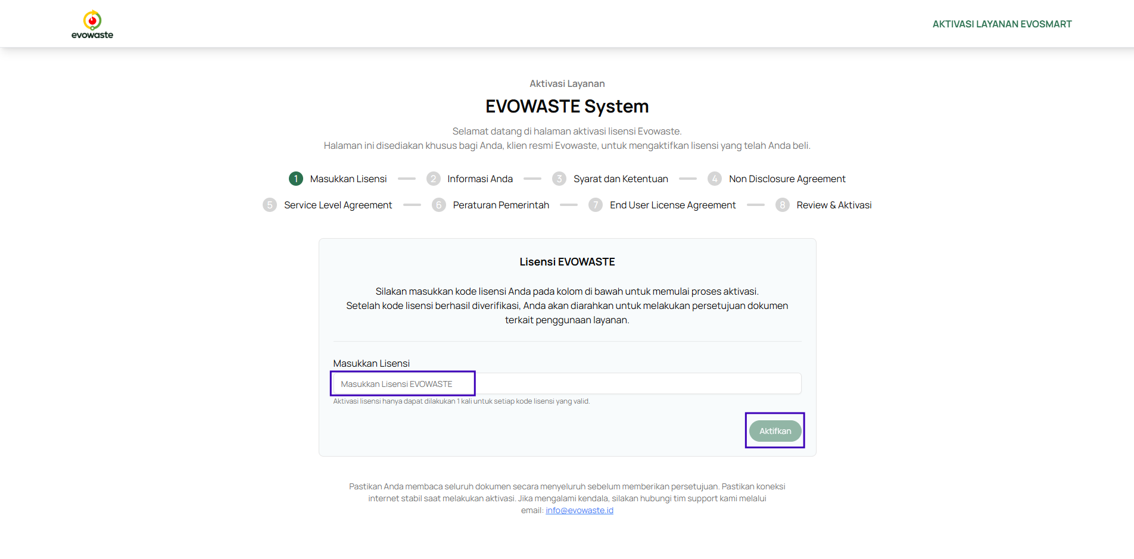

After filling in the Evowaste License Code you will be directed to your Service information page.

**5.2 Confirmation of EVOWASTE Service Information**

On the Evowaste Service Information Page, information on the License Code, Company Details, Device Details and Evowaste Services is displayed.

1. **License Code Information and Company Details**

**The License Code & Company Details Section provide information about** Company Details of Company Name, Company Address, PIC Name, Telephone Number, Email, and Site Address.

Make sure all company details are correct. If there are errors in your company details, you can contact the admin to update your company data.

1. **Evowaste Device and Service Details**

**Evowaste Device and Service Details Section** displays information about the machines used and services from Evowaste.

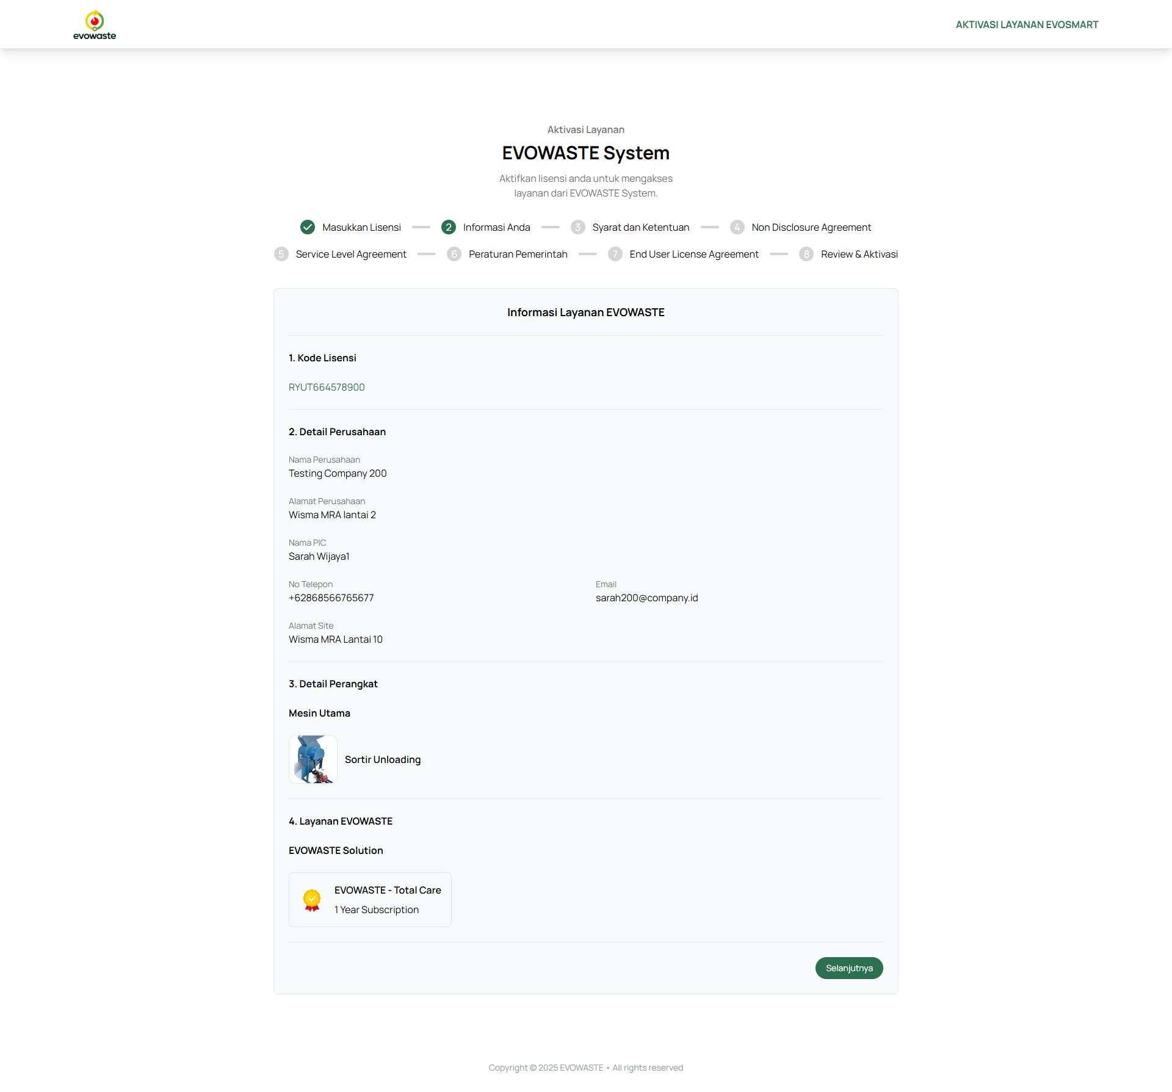

If all the Evowaste Service Information is correct, click the “**Selanjutnya**” button and you will be directed to approve the document.

**5.3 Review and Approve Documents**

At this stage, you are required to review and agree to several documents: Terms and Conditions, Non-Disclosure Agreement, Service Level Agreement, Government Regulations, and End User License Agreement.

Please ensure you read all documents carefully before agreeing to ensure a complete understanding of the agreements you will be entering. Approving these documents is a crucial part of the activation process and serves as the legal basis for the service.

1. **Terms and Conditions Document**

The Terms and Conditions document governs the rights and obligations between the client and the Evowaste service provider. This document includes general terms of service use, limitations of liability, a privacy policy, and operational procedures applicable during the term of the agreement.

To agree with this document, you must read the entire document from start to finish and click the checkbox to agree. Once approved, you can click the "Next" button.

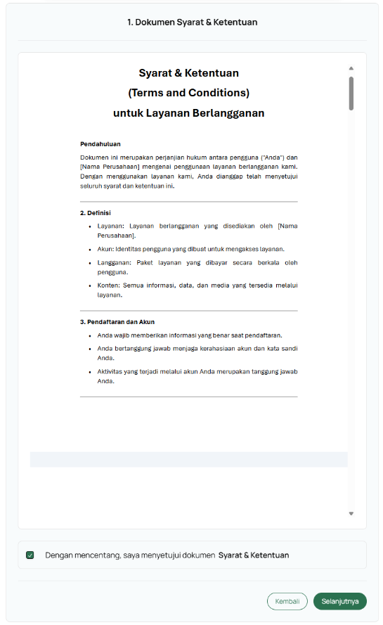

1. **Non-Disclosure Agreement (NDA) Document**

This document stipulates both parties' commitment to maintain the confidentiality of information exchanged during the collaboration. The purpose of agreeing to an NDA is to protect business data and sensitive information from misuse.

To agree with this document, you must read the entire document from start to finish and click the checkbox to agree. Once approved, you can click the "**Selanjutnya**" button.

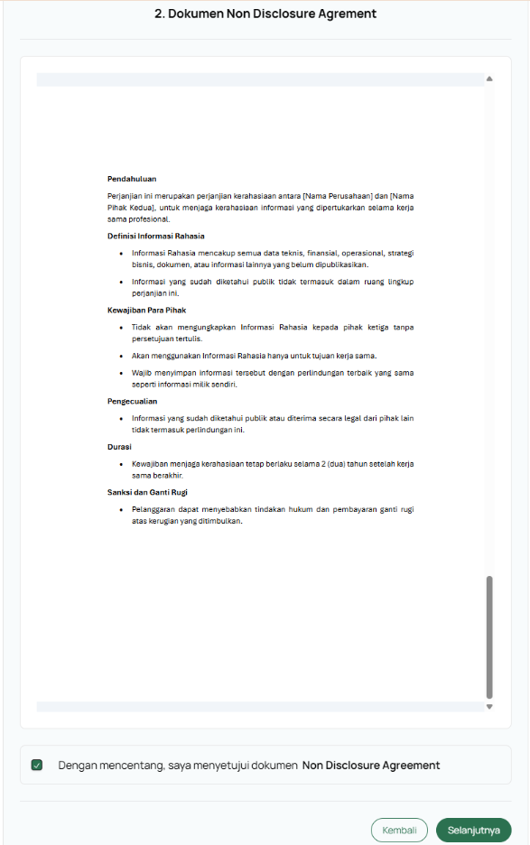

1. **Service Level Agreement (SLA)**

An SLA outlines the promised service standards, including response times, system availability, and technical support. By agreeing to an SLA, the client understands the level of service they will receive and the responsibilities of each party.

To agree to this document, you must read the entire document from start to finish and click the checkbox to agree. Once approved, you can click the "**Selanjutnya**" button.

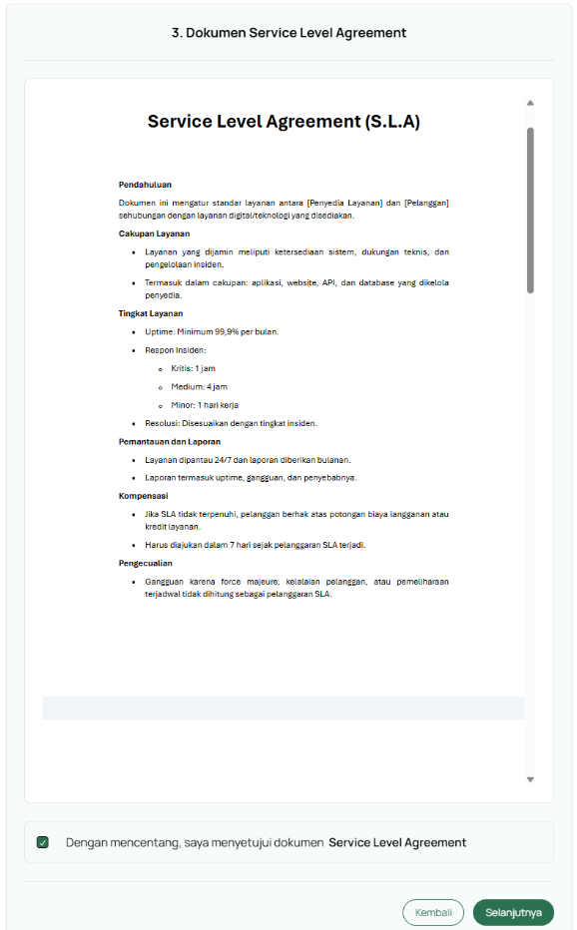

1. **Government Regulation (PP)**

Clients are required to agree to comply with government regulations and policies relevant to their use of Evowaste services. This ensures that the entire process complies with applicable laws and regulations.

To agree to this document, you must read the entire document from start to finish and click the checkbox to agree. Once approved, you can click the "**Selanjutnya**" button.

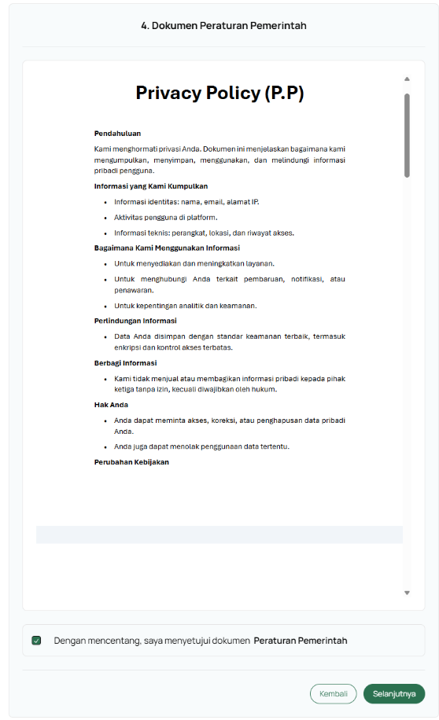

1. **End User License Agreement (EULA)**

The EULA governs the client's rights to use the Evowaste software and system. By agreeing to this document, the client acknowledges that they understand and accept the terms and conditions regarding the license, usage restrictions, and intellectual property rights.

To agree to this document, you must read the entire document from start to finish and click the checkbox to agree. Once approved, you can click the "Next" button.

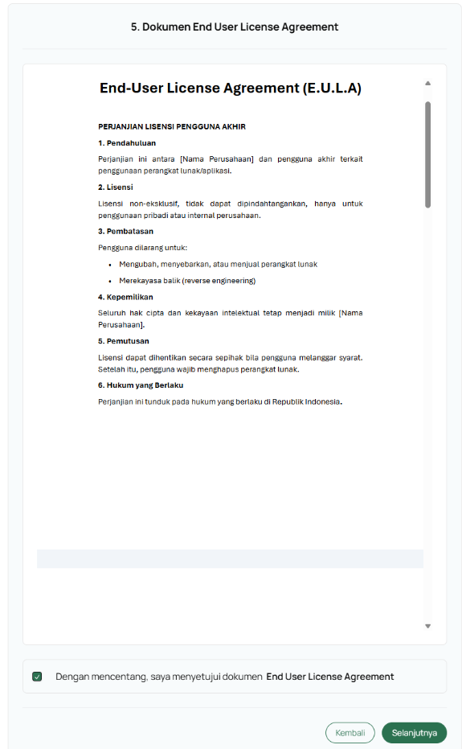

Once you've approved all the documents, you can click the **Selanjutnya** button to proceed to the service and document review page.

**5.4 Evowaste Service Review & Activation**

After completing all reviews and approving all documents. You will be shown a summary page of all the information. On this page you can download each of these documents.

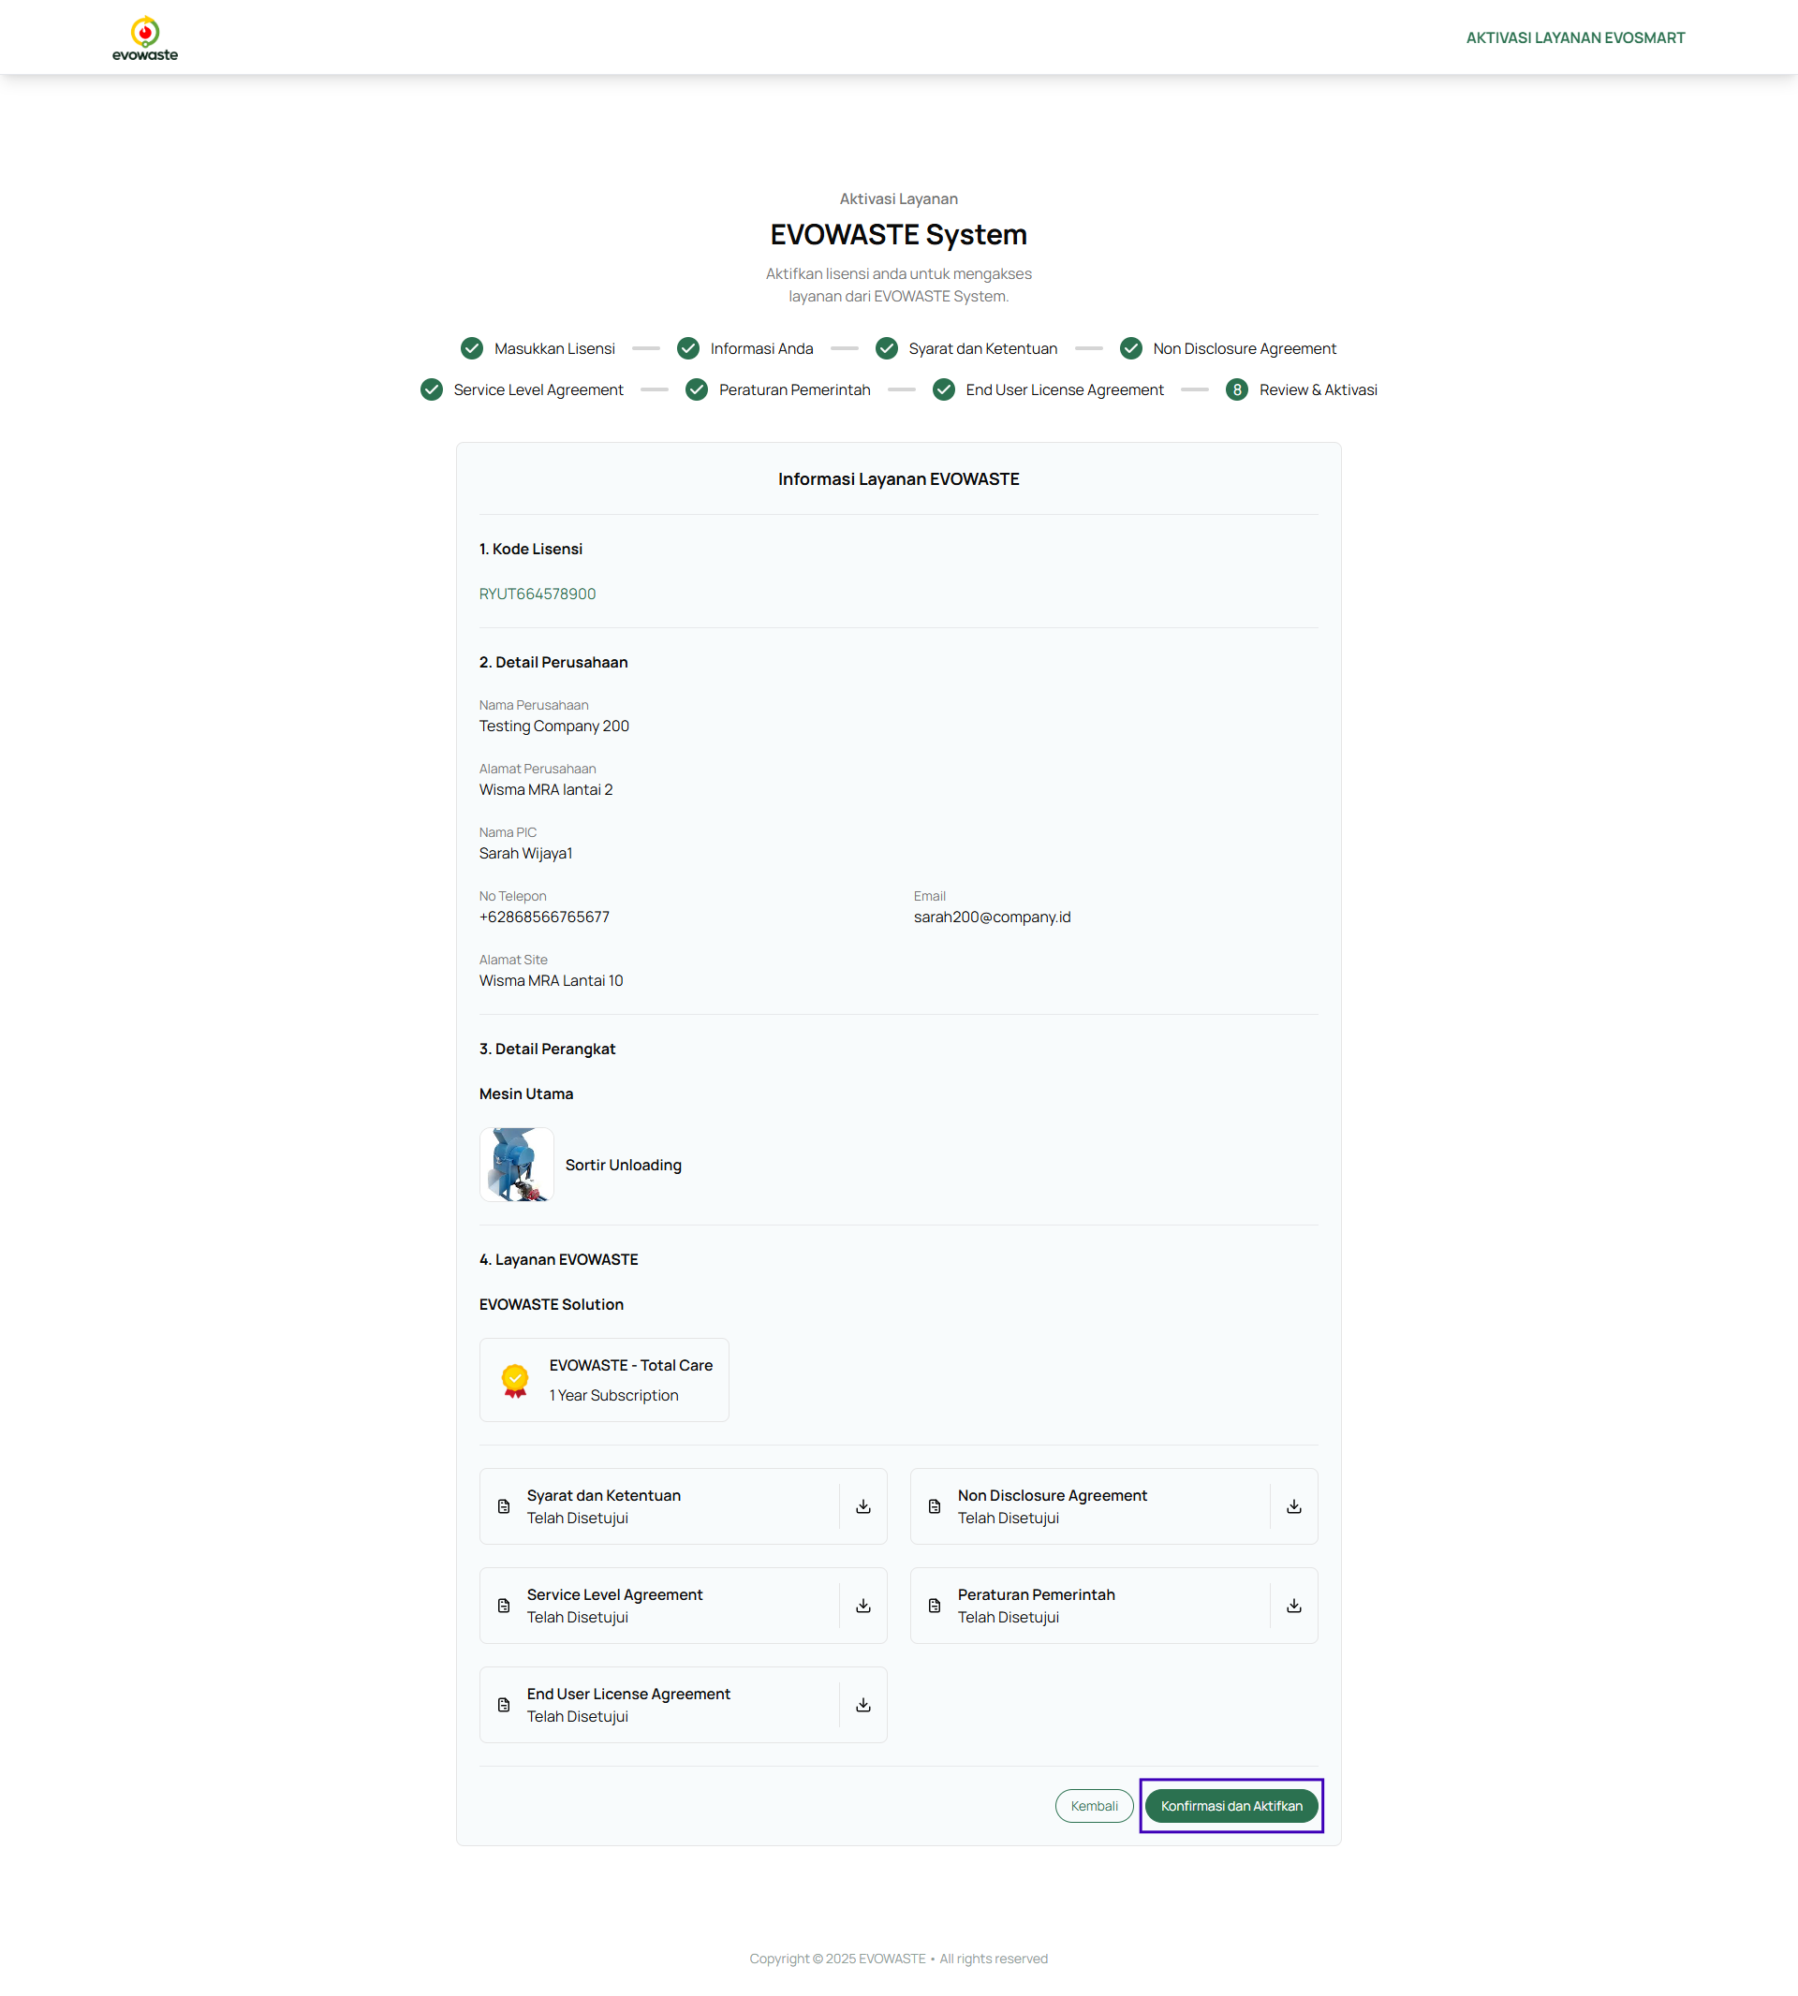

After reviewing all Evowaste service information, including the License Code, Company Details, Device Details, Evowaste Services, and all documents, you can click the "Confirm and Activate" button to confirm that the Evowaste service has been successfully activated. You will be redirected to the activation page.

**5.5 Successful Activation and Service Information**

After reviewing the Service Information and Documents and activating it, you will be directed to the "Evowaste Service Successfully Activated" page. You will then be able to access all Evowaste services and perform operational activities. Click the "Finish" button.

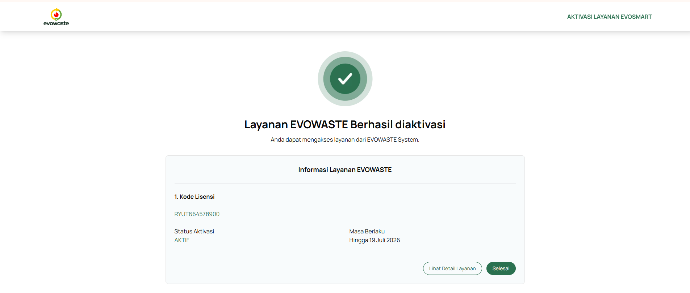

If you want to review the service information and documents, click the "**Lihat Detail Layanan**" button.

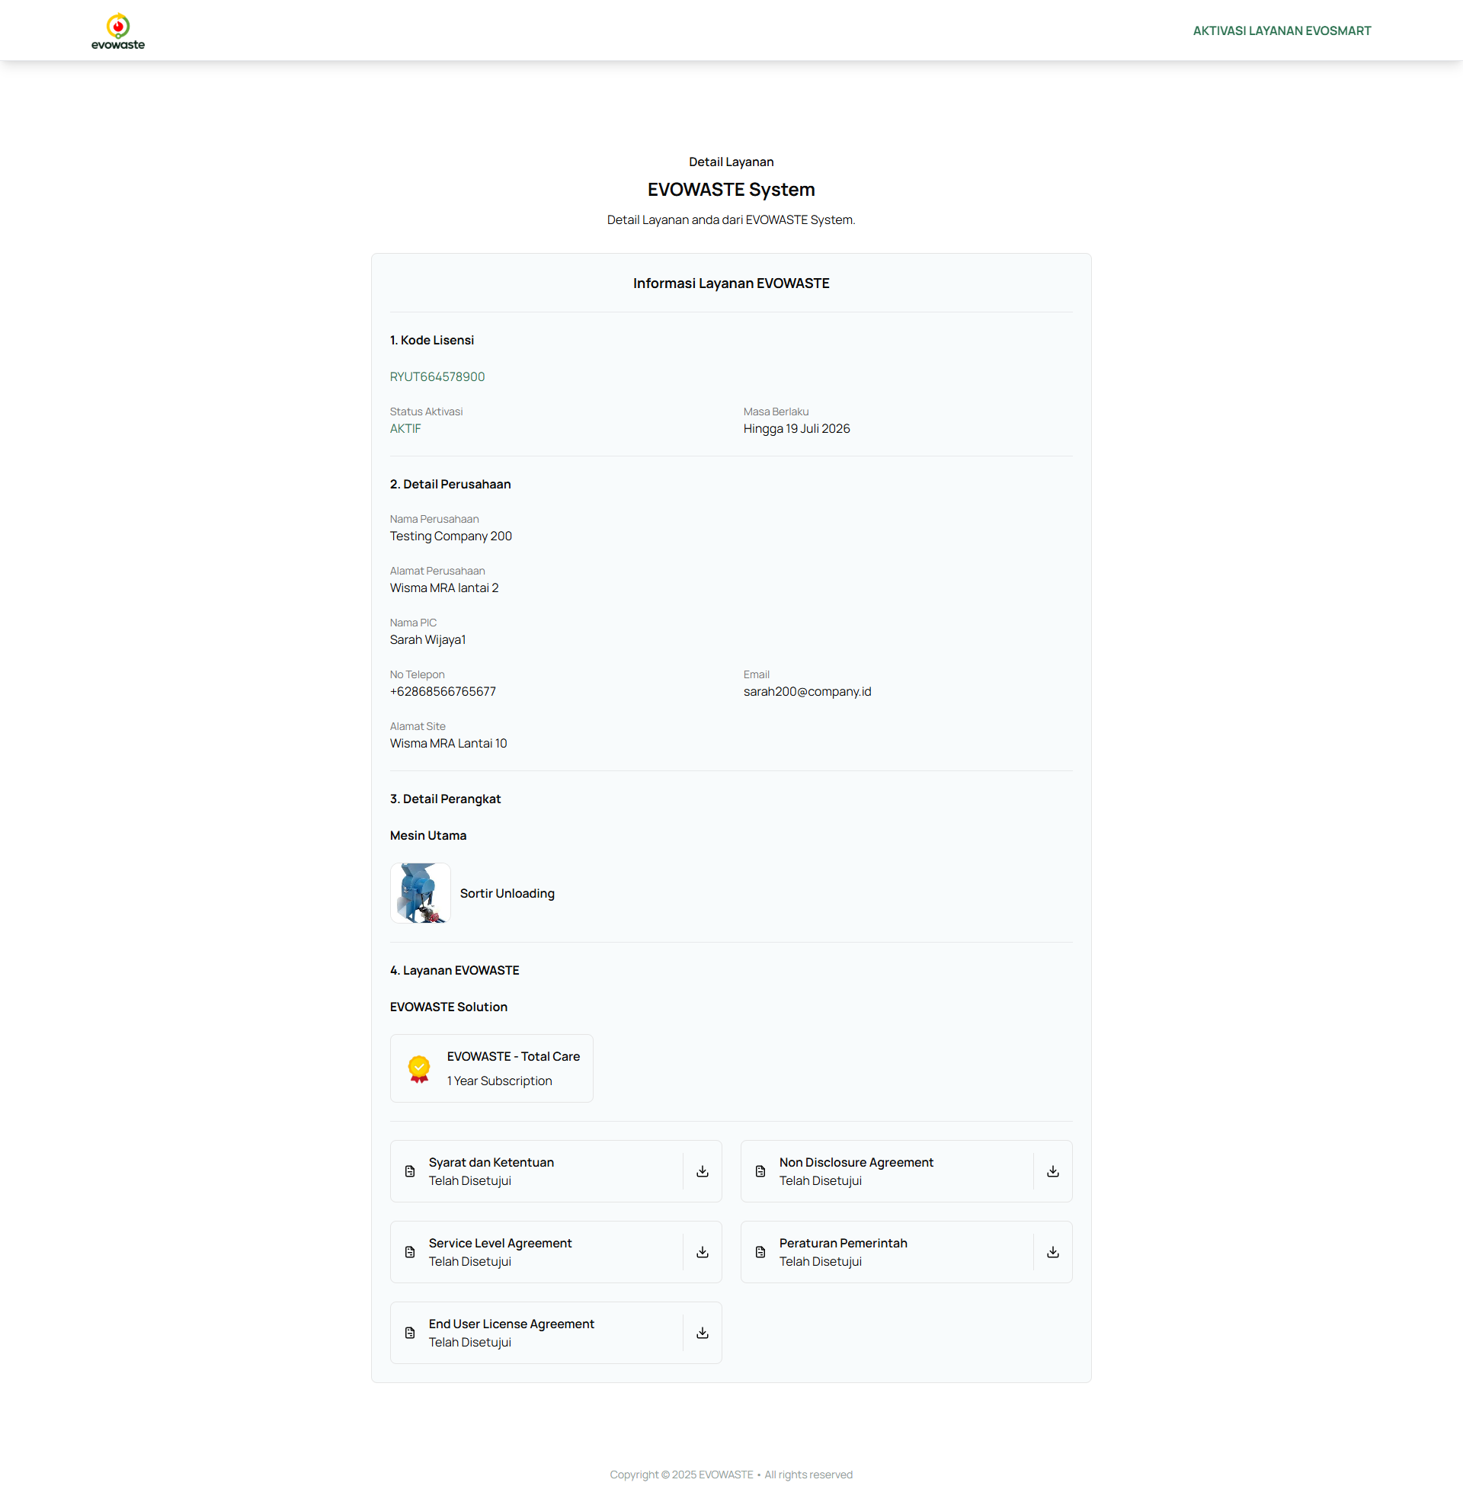

1. **FAQ (Frequently Asked Questions)**

* Unable to login: Check your internet connection and make sure the password entered is correct.
* Data is not saved: Make sure all required fields are completed.
* Page cannot be opened: Please refresh or try using another browser.

1. **Support Contact**

* Email: [info@evowaste.id](mailto:info@evowaste.id)
* Call: +62 21 2955 3584

1. **Glossary**

* **Activation**

The process of enabling a feature, service, or software product to become fully functional, often requires a license key or account verification.

* **Subscription**

A recurring agreement that allows a user to access a product or service for a specified period, typically requiring payment at regular intervals (e.g., monthly or annually).

* **License Code**

A unique alphanumeric key provided to a user to activate or validate a software product or service. It serves as proof of purchase or authorization.

* **Service Expiration Date**

The specific date when access to a service or product will end unless renewed. After this date, the user may lose access or functionality until a new subscription or activation is completed.

1. **Attachment**

